DIRECTIONS TO THE ABBEY

The Abbey
Abbey Road, Great Malvern, Worcestershire WR14 3ET
Tel: 01684 892332 Guest Fax: 01684 892662
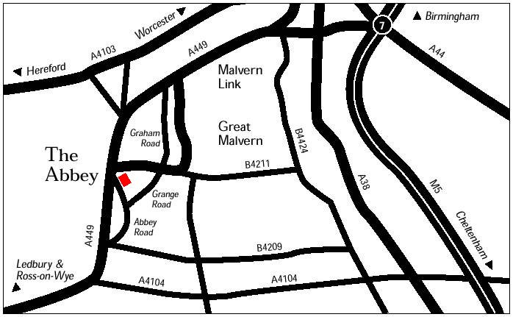
BY ROAD

M5 North
Exit Junction 7 and take the A449 for 9 miles through the Malvern Link Town towards Great Malvern. After the Malvern Link Common, on the left hand side, turn left into Graham Road. After the traffic lights go straight into Grange Road. Travel to the end and take a sharp turn right into Abbey Road. The Abbey Hotel is on the right at the top end before the Abbey Gateway.

M5 South
Exit Junction 8 and take M50 to Junction 1.Take A38 for 3 miles and turn left onto the A4104. Once across the bridge at Upton-upon-Severn turn right onto the B4211 towards Malvern. Enter Malvern through Barnards Green, at the roundabout take the third exit into Barnards Green Road. Turn left at the traffic lights and at the end of the road take a sharp right into Abbey Road. The Abbey Hotel is on the right at the top end before the Abbey Gateway.

BY RAIL
Great Malvern Station is situated on the Intercity Rail Network between London Paddington and Hereford. The station is situated less than one mile from the Abbey Hotel.

BY AIR

Birmingham
Birmingham International Airport 38 miles M42, M5, Junction 7.
London - Heathrow
Take the Heathrow express direct to London Paddington Station, then follow directions for “By Rail”.

