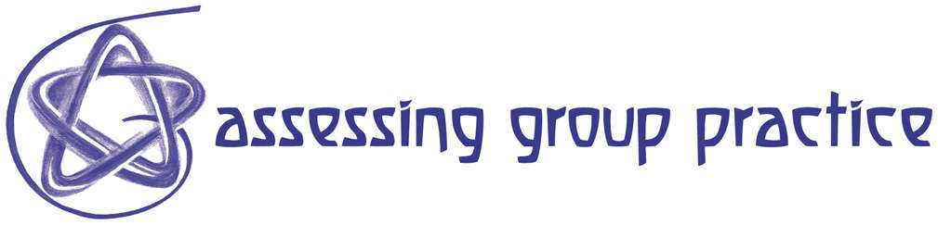
Resource 89 Planning Collaborative Learning - Key Questions

1. How appropriate is collaboration for achieving the
stated teaching and learning goals?

2. How appropriate is the assignment for collaboration?

3. How clear are the expected learning outcomes?

4. How clear are the evaluation criteria and standards?

5. How clear is the collaborative process?

6. How clear are the learners’ roles and responsibilities?

7. How clear is the instructor’s role and responsibilities?

8. How well prepared are the students?

9. What formative feedback will they get and when?

10. What problem-solving resources are available
to learners when problems arise ?

