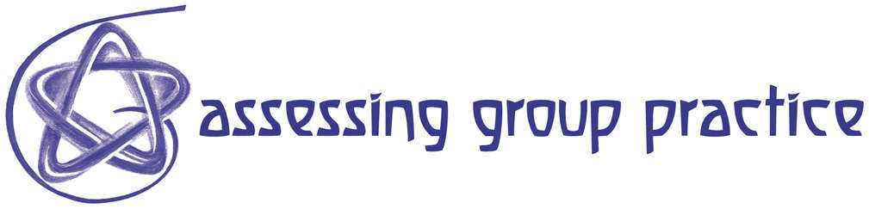
R16 How to raise self-awareness when working in a group

Over the next week, listen to yourself talking in different contexts such as a seminar group, with different friends, to someone in authority and with your family.
- Are you going on too long?
- Are you embellishing?
- Are you making little, subtle jabs at people?
- Are you unconsciously working to express your own importance or superior knowledge or your lack of stature in the group etc.?

Try to be honest with yourself. We all do these things on occasions but few of us are required to observe ourselves critically. It might help you to keep a log of particularly memorable conversations and jot down how you communicated and what you felt. By observing ourselves (and others) talking we become conscious of both good and bad habits. A log or diary can help you to track your progress and so see how you have 'improved' over the week.

When participating in group work, whatever you need to say needs only to pass the simple test of teamwork: Are you saying something that is germane to the team as a whole? Is it relevant to the group's
- objectives?
- overriding vision?
- tasks it has set out for itself?

Remember to be direct, relevant and respectful of others.

You may want to refer to (R15) for ways of improving communication.

