Instructions for REAMS - Applicants
Document Contents
1. Log in: 2
2. The General System of REAMS 2
3. The Work Area Screen 3
3.1. The Work Area 3
3.2. Folders: 4
3.3. Projects: 5
4. Two different workspaces: “outside the form” and “in the form” 6
4.1. Working outside the application form: 6
4.1.1 Navigation overview tab 6
4.1.2. Other tabs in the application overview page 7
4.2 Working inside the application form: 7
5. Create your application 8
6. Receiving comments and correcting your application 14
7. Notifications and Correspondence 17
7.1 Correspondence 19
8. Amendments 21
Amendments to applications which require HRA approval and FREC approval 30
9. Other functions 25
9.1. “Share” your application 25
9.2. Correspondence in the Application Overview Actions box 26
9.3. Print your application or view as a PDF 26
9.4. Automatic submission 27
9.5. Project: 27
9.6. Refresh button in Actions box of applicant overview site 28
9.7 Adding contacts in REAMS and changing your personal details 28
9.8 Useful contacts 29
Appendices 30
10. Appendix 1: Guidance specifically for staff and PhD students in the Economics Department 30
11. Appendix 2: Guidance specifically for staff and PhD student research requiring HRA approval and
Faculty Research Ethics Committee approval…………………………………………………………………………………… 30
12. Appendix 2: Guidance specifically for amendments to research requiring HRA approval and
Faculty Research Ethics Committee approval .......................................................................................30

1. Log in:
Whilst REAMS “runs” on all browsers, we recommend the use of Chrome for the best user experience.
Use this link to access the applicant side of REAMS known as ‘Forms’: https://reams.lancaster-university.uk/ActivityForm/Index
Login name: your Lancaster e-mail address
Password: Lancaster1 (or your personal password in case you had changed it)

2. The General System of REAMS

- Application form: In REAMS all the questions that used to be part of the ethics application form are now inbuilt into the system. The program leads you from one question to the next. REAMS is interactive and only those questions that follow your earlier answers will appear.
- Self-review: REAMS can determine if you project is simple enough ‘low-risk’ that you can get approval without a review by the research ethics committee. This is called a self-review and you may get an immediate authorization for you study. If your answers indicate a more complicated or ‘high-risk’ ethical situation, you will be guided though the full form.
- Attachments: The parts that were additional files until now, such as a Participation Information Sheet (PIS), Consent Form, Questionnaires, Invitations etc. (all long documents) will still be separate and will be uploaded into the system either as word or pdf file.
- Finishing your application: Once all documents are uploaded you can press “completeness check”, the system will check if you have filled all the sections needed and will show you the missing or incomplete sections. At the end of the application is the REC (Research Ethics Committee) declaration, similar to the final section in the current paper-based application form. You must confirm that you comply with all the points and then sign at the end. Once you sign, the application “closes” and is sent to the Research Ethics Officer or for additional signature to your supervisor.

For ethics-related queries please contact your Faculty Ethics Officer:
- For FHM and FST related queries
- For FASS and LUMS related queries
For questions related to the REAMS system please email reams-support@lancaster.ac.uk
Further advice and guidance can be found on your Faculty Research Ethics web page:
- FASS-LUMS
- FST
- FHM

3. The Work Area Screen

3.1. The Work Area
1
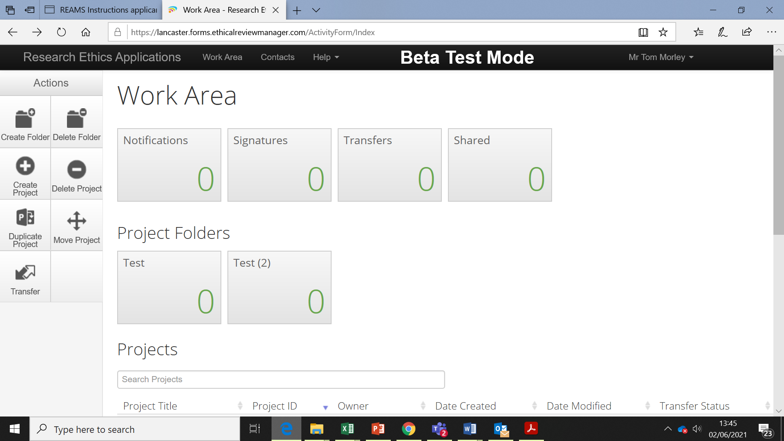
2
Figure 1- The work area
Once you are logged into the system the ‘Work Area’ screen will open (Figure 1). The work area is essentially the REAMS home page. The left-hand side of the page contains a number of buttons in what is known as the Actions box (shown by the red box, Figure 1).
The Work Area (Home), provides you with an overview of all of your applications (known in the system as Projects). You can always get back to the Work Area screen by pressing “Work area” tab on the top row (red arrow (1) in figure 1).
The “Notifications” button is also present in your Work Area box (green arrow (2)). You may receive a notification for a variety of reasons, ranging from messages from a reviewer to confirmation that your application has been approved (see Section 7 (Notifications)).
The Actions box contains a variety of functions that change depending on whether you are “outside the application” or “inside the application” (Please see section 4 for more information on this). Depending on which level of the program you are working in only the appropriate buttons are presented. Therefore, if you do not find the button you are looking for you might be “on the wrong level” and thus looking in the “wrong” Actions box. To return to the work area simply press the ‘work area’ tab at the top of the page (Section 4).
The following actions can be performed in the Work area Action Box a) Create Folder, b) Delete Folder, c) Create Project, d) Delete Project, and e) Duplicate project f) Move project g) Transfer. Transfer can be used to transfer the application to a colleague who will then become the owner of the application.

3.2. Folders:
3
1
2
Figure 2- Folders
The REAMS system allows you to sort your applications into folders. We recommend creating a folder only for applications that have been finished. Please note that once an application has been moved into a folder, it cannot be duplicated any more. Duplication is a useful tool if many aspects of an application for two different projects are the same and can be created by pressing the “Duplicate Project” (Blue arrow (1)) button in Actions box.

To create a folder, navigate to your work area and click “Create Folder” in the Actions box (Red arrow (2)). To move an application (known as ‘Projects’ in the REAMS system) into a folder, click “Move Project” (Green arrow (3)) in the Actions box and then indicate in the new window which application or project you would like to move into which folder.

The following actions can be performed in the Work area. a) Create Folder, b) Delete Folder, c) Create Project, d) Delete Project, and e) Duplicate project f) Move project g) Transfer. Transfer can be used to transfer the application to a colleague who will then become the owner of the application.

3.3. Projects:
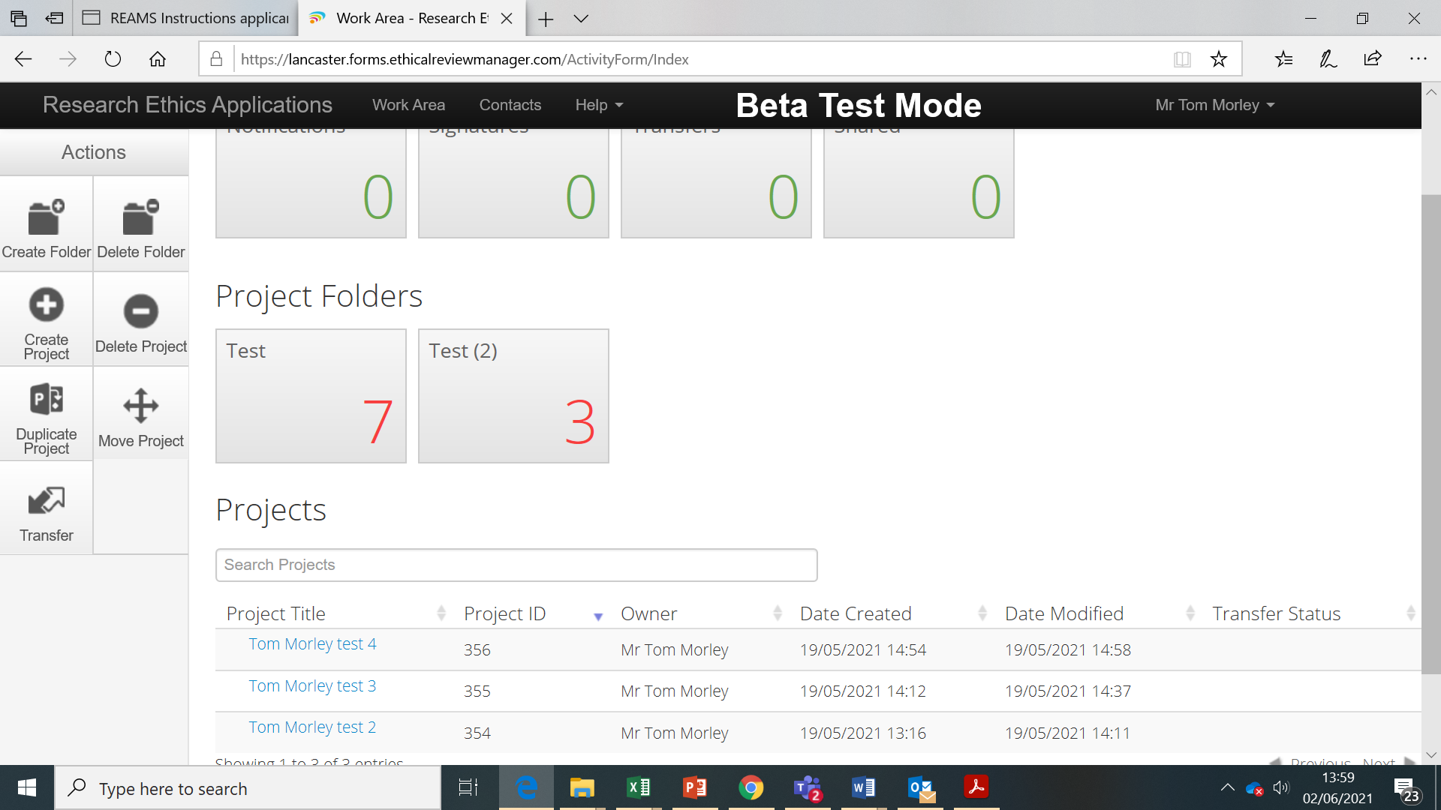
3
2
1
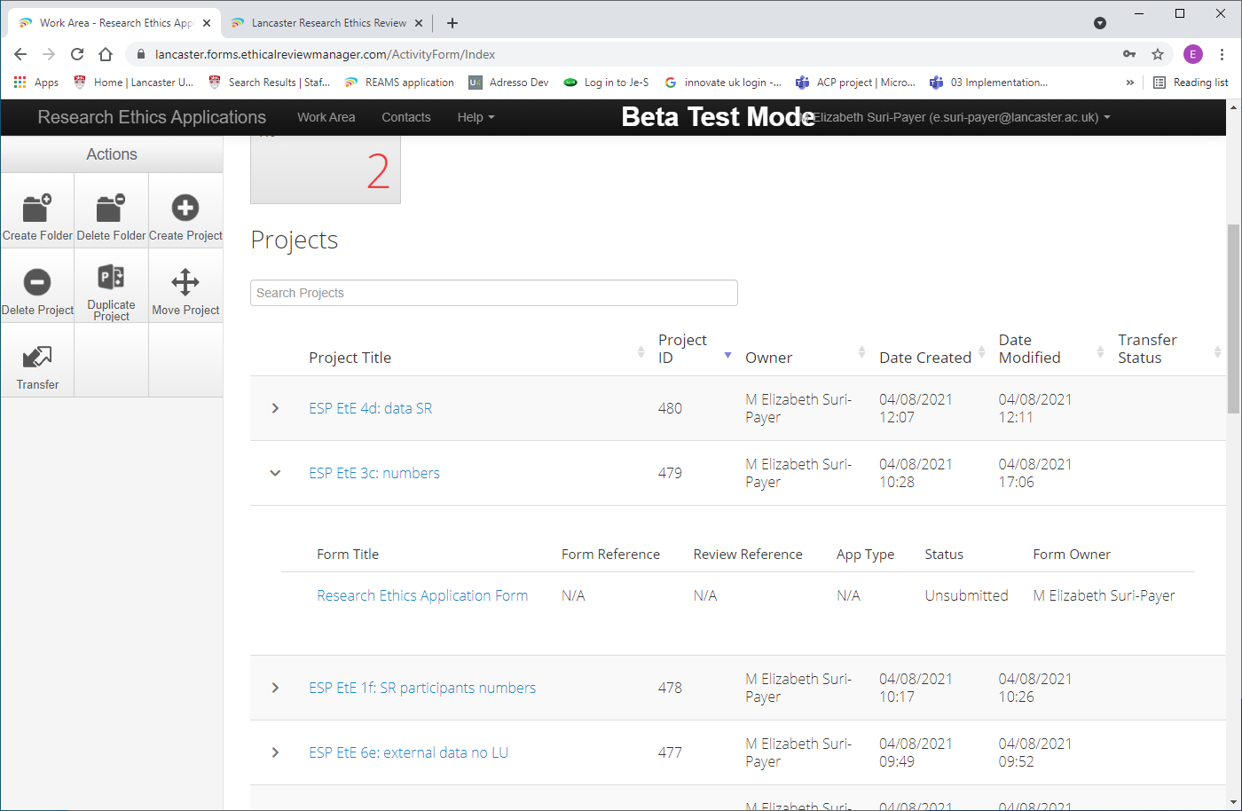
4

Figure 3- Projects
The project list shows all applications (projects) that have not been stored in a folder. The project list shows the project title, the project ID (Blue arrow (1) figure 3) and owner, and dates the project was created and modified. There are arrows on the left side of each project list rows (Orange arrow (4) figure 3). Clicking on these arrows provides more information about the application such as its current status. Simply click on a folder to see the projects within it (Red arrow (2) figure 3).

Projects can be created or deleted from this Work Area window with the “Create Project” and “Delete Project“ buttons in the Actions box. See section 5 for information on how to create an application (project).

You can also transfer your application to a colleague who will then become the owner of the application by pressing the “Transfer” button (Green arrow (3) figure 3)

4. Two different workspaces: “outside the form” and “in the form”
In order to work in REAMS one needs to appreciate the difference between working outside the application form and working in the application form.

4.1. Working outside the application form:
This means working on the outside of your application. The Work area, described in section 3 is where you create new applications and manage all of your existing application. When you click onto one of your applications the application overview page (figure 4) will open. The application overview page is also ‘outside’ of your application form and acts as a ‘home page’ for individual applications. The functions contained within the Actions box in the application overview page will be explained later on in this guidance document.
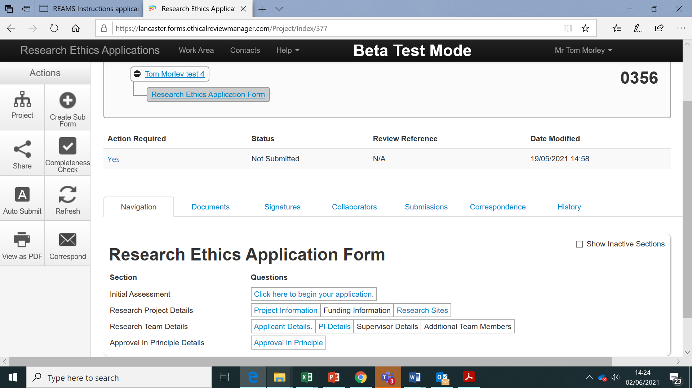
Figure 4- Navigation overview in the application overview

4.1.1 Navigation overview tab
The lower part of the screenshot in figure 4 shows the navigation overview tab page, since the “Navigation” tab had been selected (red box in Figure 4). The application form is divided into many sections under the sub-heading ‘Research Ethics Application Form’ that appear depending on the previous answers provided within the application form. This formatting also makes it easier to navigate to specific sections of your application.

The example above depicts the navigation overview of an application form. Each box with blue text shows a section of the application form that has been completed. You can navigate directly to each of these sections by clicking on a box with the blue text.

4.1.2. Other tabs in the application overview page
The applicant overview also shows uploaded documents, signatures, collaborators, submission dates, correspondence and history. You do not need to use these in creating your application as these functions are also contained within the application form in REAMS.

4.2 Working inside the application form:

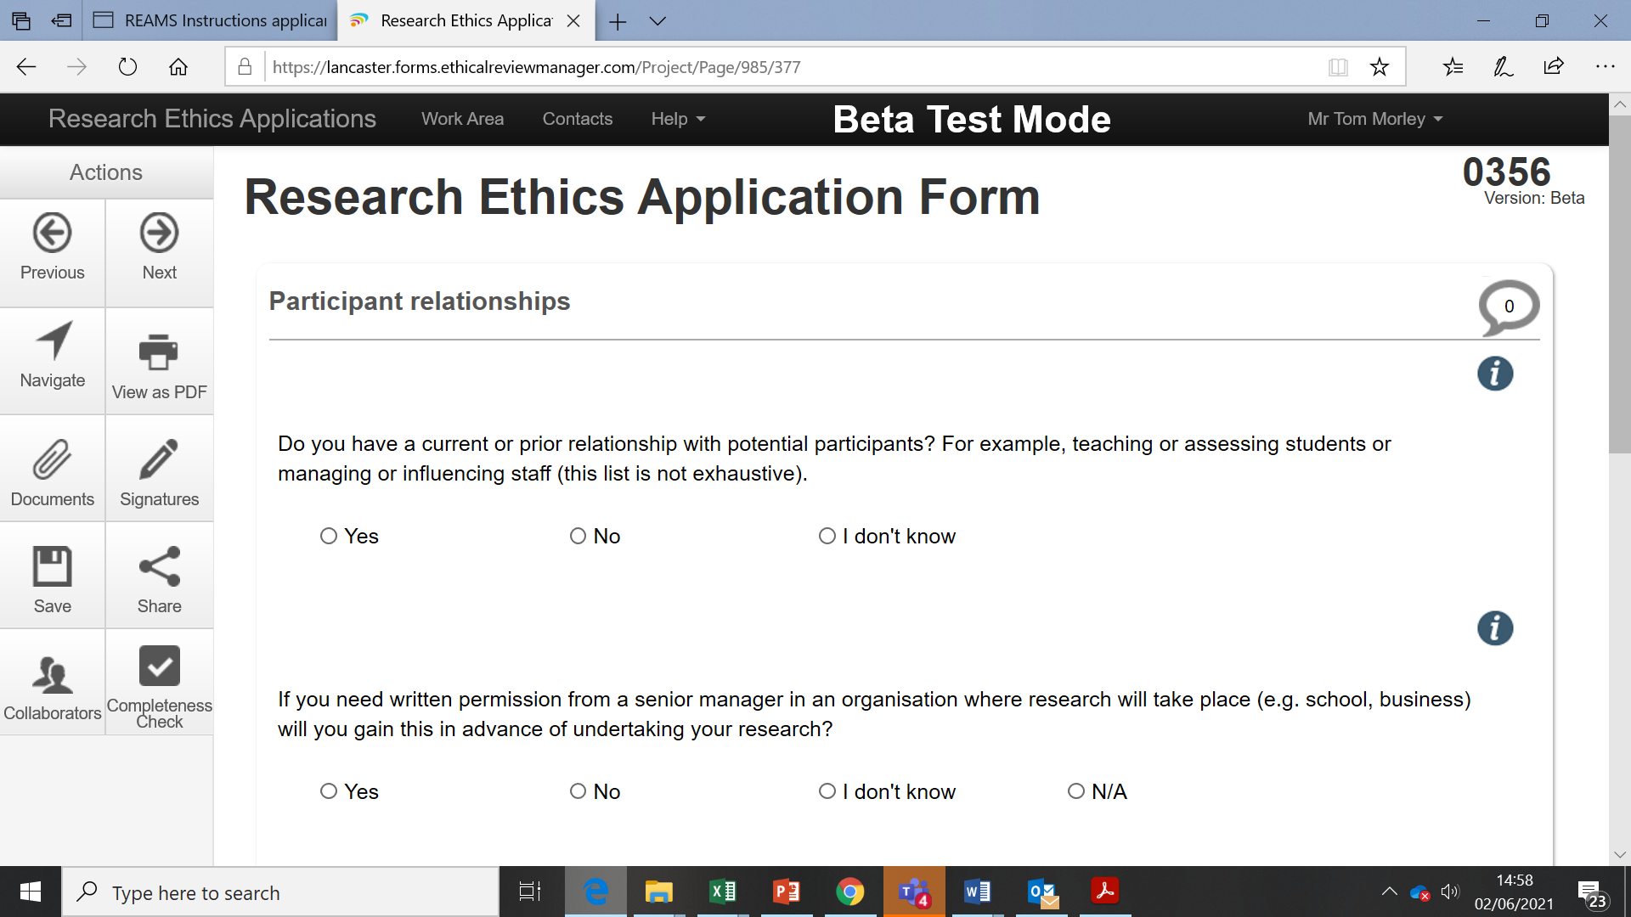
2
1
Figure 5- Working in the application form.
Working ‘inside’ the application form refers to working on the application itself. You can navigate between pages in the application form by clicking the "Next" button located in the Actions Box (Red arrow (1) figure 5). If you “get lost” inside an application, click the “Navigate” button (Blue arrow (2) figure 5) in the Actions box to return to the application overview page show in Figure 4. More information about working inside the application form is provided in the next section.

5. Create your application
Before you begin an application, we strongly recommend that you add your own personal details and the contact details of any one else associated with the application (such as your supervisor or members of your research team) into the REAMS system. Please see section 9.7 for details on how to do this.
To start a new application click “Create Project” in the Actions box in the Work Area overview screen (Red arrow (1)) shown in figure 6.
2
1
Figure 6 - Create project
The window below will appear (Figure 7). Fill out the project title, and choose ‘Research Ethics Application Form’ from the ‘Main Form’ drop down box, then click Create.
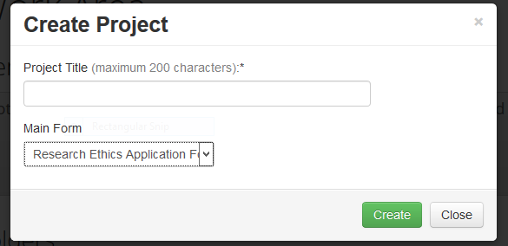
Figure 7- Create your application.
To duplicate an existing application, click first on the “Duplicate Project” button in the Actions box (Green arrow (2) in figure 6) and then choose the project you like to duplicate (figure 8). This tool is useful if you wish to submit an application which contains similar material to a previous application.
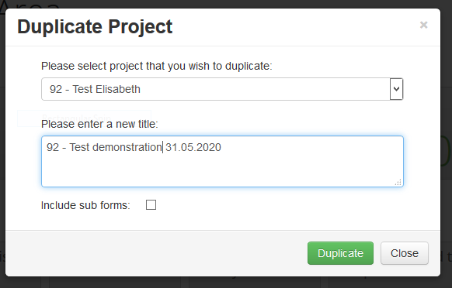
Figure 8 - Duplicate project
After clicking create project or duplicate project, the application overview page for the new project will open (please see section 4.1). Within the page you will see a project tree with the name of your new application (Blue arrow (1) in figure 9), and at the bottom the Navigation overview under the navigation tab, which is almost empty at this stage (shown by the green box (2) in figure 9). You can start your application by clicking “click here to start your application” (Red arrow (3) in figure 9).
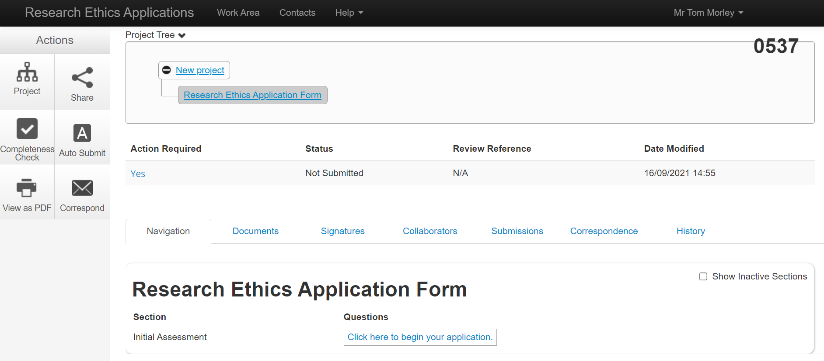
1
3
2
Figure 9 –Create your application.

You will then be directed to the first page of your application form (shown in figure 10):
4
1
3
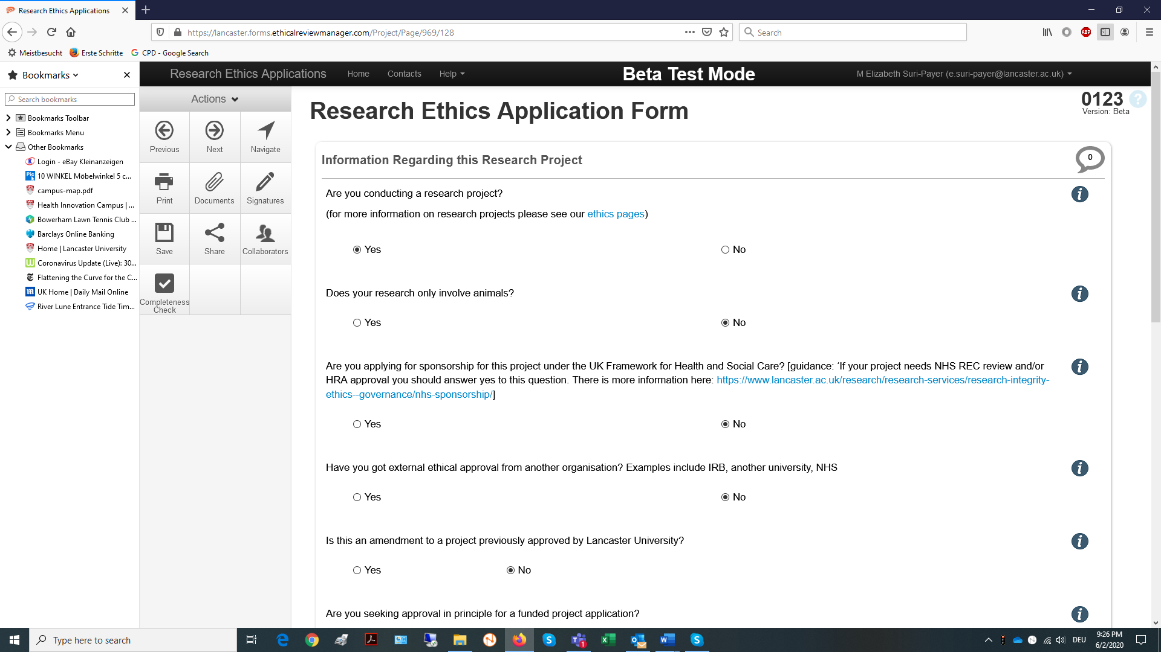
2
Figure 10- Application form first page.
The “i” button next to each question provides you with additional information and guidance. At the end of each page, click the “Next” button on the upper left side of the Actions box to navigate to the next page (Red arrow (1) figure 10). Navigation arrows can also be found at the bottom of all pages. The program will adjust the questions you are required to answer based on your previous responses.
If you have to stop working on the application, you can press ”Save” in the actions box to save your work (Green arrow (2) figure 10). If you need to go back to a page you have already answered click the “Previous” button (Blue arrow (3) figure 10) or click the “Navigate” button (Purple arrow (4)) to then choose the section you wish to navigate to from under the navigation tab in the application overview screen.
After filling out all the questions in the application form you will need to upload any additional supporting material such as PIS, consent form, questionnaires, etc. that you will be using as part of your project. You will be able to find templates for these documents on your faculty research ethics webpages. To upload these documents to REAMS click the blue ‘Upload document’ button shown in the red boxes in figure 11.
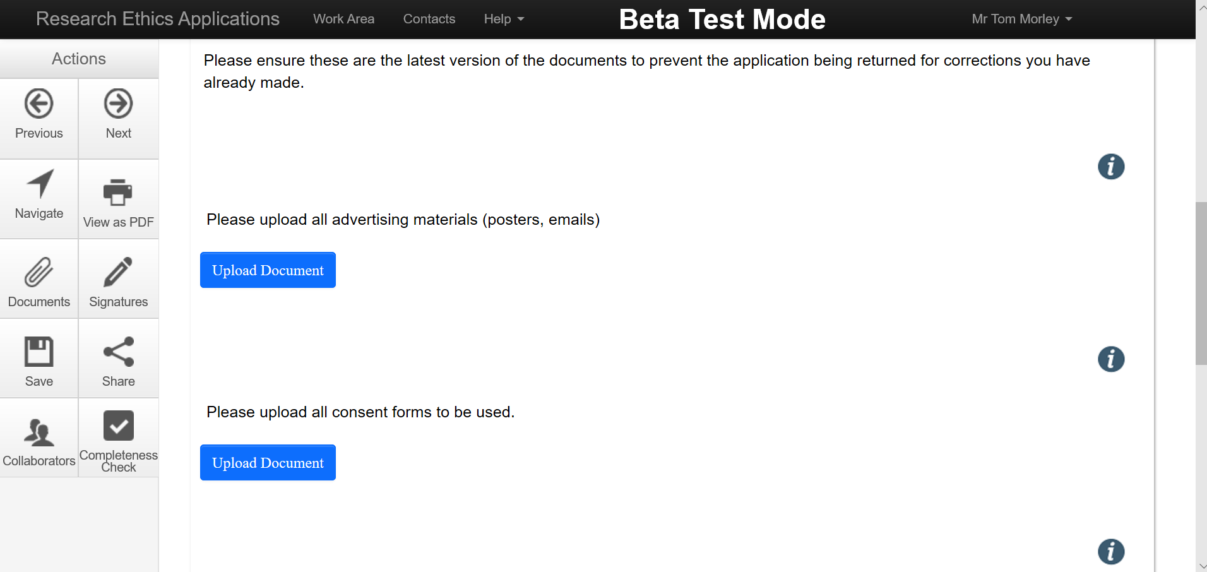
Figure 11- Upload document
Once you have clicked the ‘Upload Document’ button, the ‘Documents Upload’ screen appears.
It is very important that you indicate the correct date and version numbers of the uploaded documents in order to not confuse the reviewer when your later upload amended documents during review (Section 6). For example, if you have uploaded a new version of your PIS, make sure that you indicate that this is version 2 of the document in the documents upload screen. All document versions will be stored in REAMS. You can find all of your associated documents under the documents tab in the navigation home screen. The REAMS system also allows you to delete files uploaded by mistake by pressing ‘delete’.
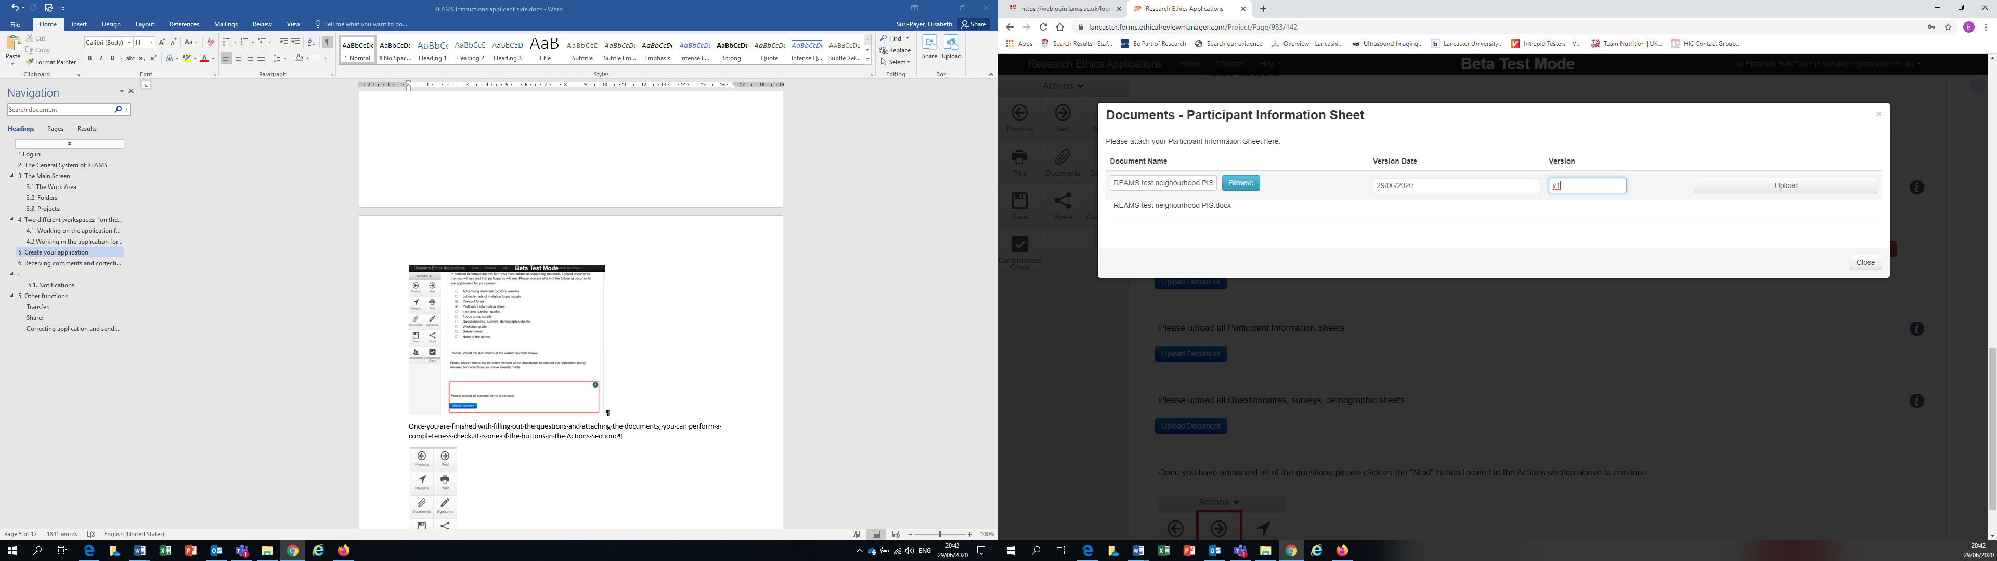
Figure 12- Document name and date

Once you have worked through all of the questions the system has asked you to answer and uploaded the necessary documents, you can perform a completeness check to see if you have missed anything. To do this simply press the ‘Completeness Check’ button in the bottom left of the Actions sidebar (highlighted by the Red arrow in figure 13).
Figure 13- Completeness check button
The completeness check will prompt you if information or an attachment is missing. Click on the blue text shown in the completeness check pop up box to navigate to the section of your application with the missing answers (Illustrated in figure 14).

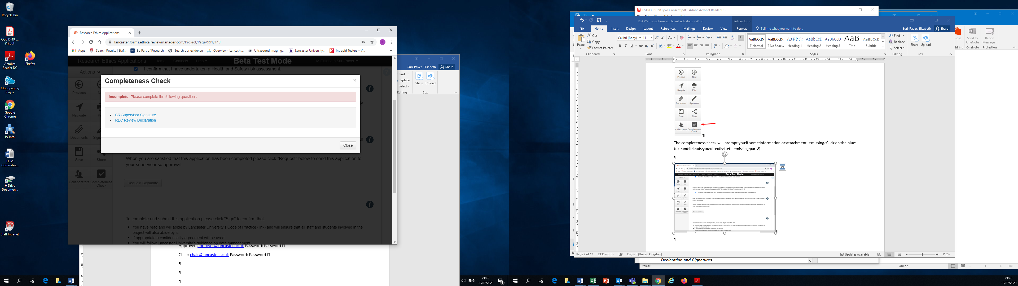
Figure 14- Completeness check navigation

Students applying for ethical approval will need to request their supervisors signature before they can close their application. To do this click on the ‘Request signature’ button shown in figure 15. This button will appear on the final page of your application form. After you have pressed this button your supervisor will automatically receive an email asking them to provide their signature. They will also receive a notification within the REAMS system in the Work Area page.
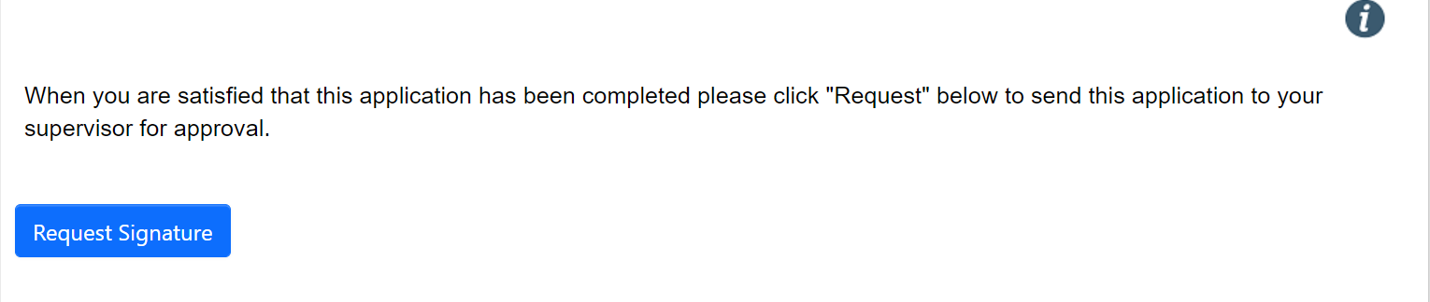
Figure 15- Request signature

The last step of the application process is to sign the declaration shown in Figure 16. Once you ‘sign’ the application, the application will lock itself for review (Figure 17). Once an application is locked you cannot go back to make changes. Only your faculty Research Ethics Officer can unlock an application upon request.
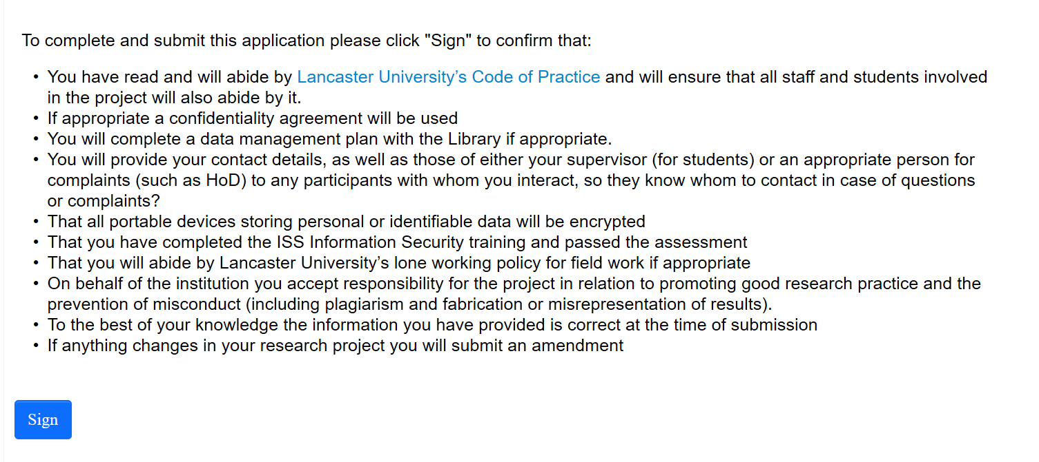
Figure 16- Declaration

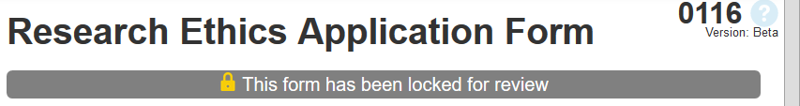
Figure 17- Application form locked

6. Receiving comments and correcting your application

Once the review process has been concluded, the you will receive the notification letter via email shown in Figure 18 containing comments from your reviewer.
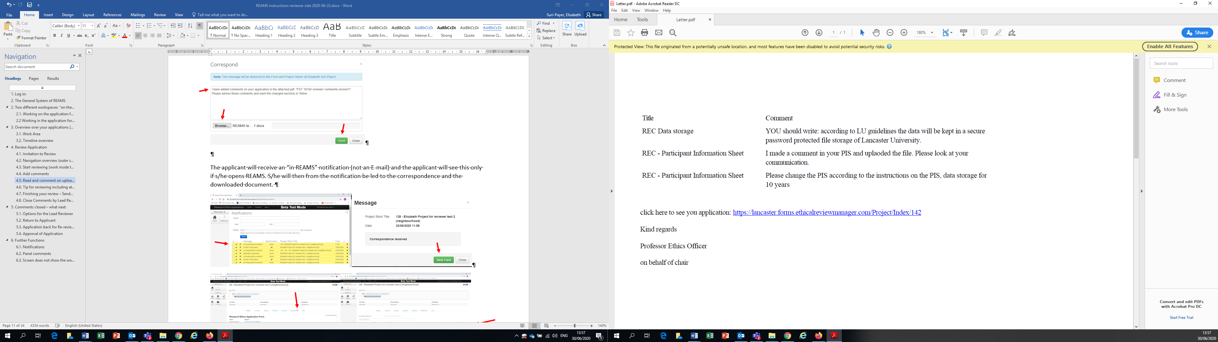
Figure 18- Reviewer comments

Clicking on the link in the notification letter will lead you to the REAMS log-in page. When you log-in, the application overview page of the application in question will open:
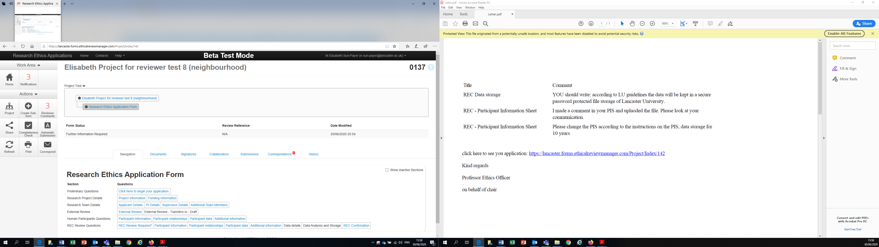
Figure 19- Application navigation overview page
In this example (Figure 19), 3 comments were added by the reviewer and 3 notifications were received (shown by the two red arrows). Please make sure to check your notifications as they provide additional information related to your comments. For example, the reviewer might have sent you a file containing further information in addition to their comments.

Clicking on the button “Reviewer Comments” will open the “overall review panel comments’ window shown in Figure 20.
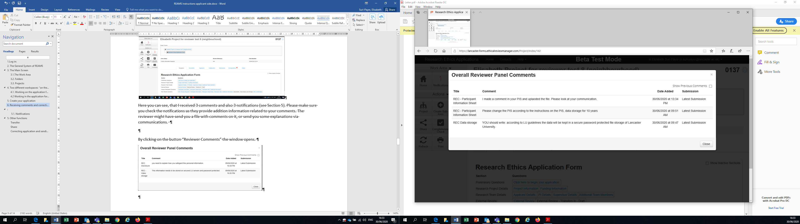
Figure 20- Reviewer comments
When you click on the text in the ‘comment’ column, REAMS will lead you directly to the section in your application form where the comment have been added. For example, in Figure 20, clicking on the second comment will direct you to the section where the PIS Form was uploaded. If you need torevise an uploaded document, then please delete the document (V1) and upload a new one (V2). Deleting the old form and giving the new attachment a new versions number is very important to avoid confusing your reviewer. “Deleting” a form means that the attached document is no longer visible to the reviewer as part of your application, however it will still be available in the REAMS system under the ‘Documents’ tab in the application overview page if you need to go back to it.
In this example (Figure 21) version 1 of the PIS has been deleted and a new version 2 of the PIS added and labled as ’V2’.
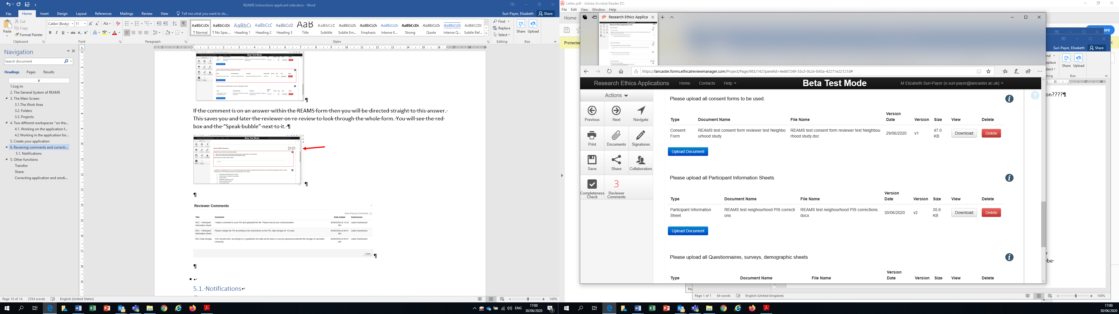
Figure 21- Delete and re-upload documents

If the reviewer comment is in response to an answer you had typed into the REAMS form, then you will be directed straight to this answer. You will see the red box and the “Speech bubble” next to the answer in question indicating that this answer has a comment from the reviewer (Figure 22).

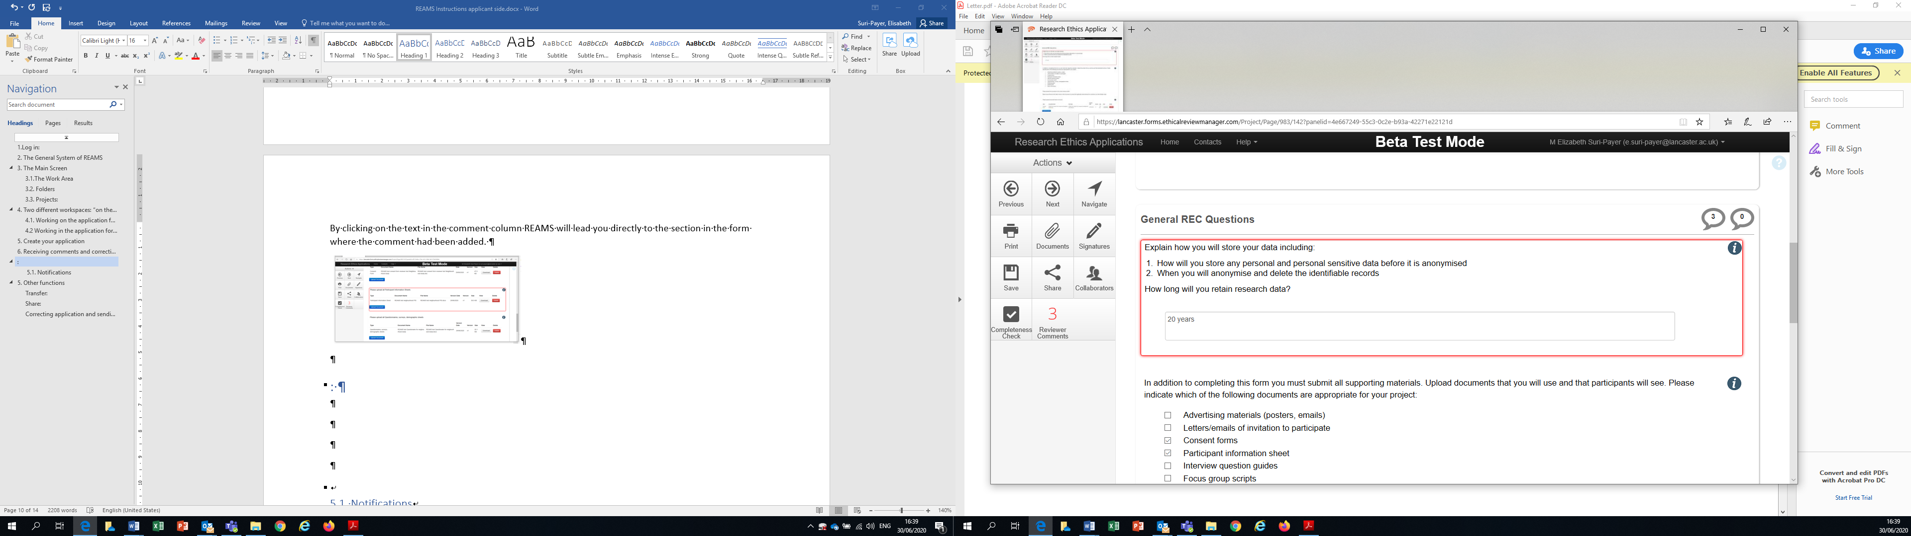
Figure 22- Free text answers
Once you have finished revising your application navigate to the last page of the application and sign the declaration again. If you are a PhD student you will need to request your supervisors’ signature to sign off these revisions before re-submitting your application. The form will then be closed and submitted again.
As you have submitted your form again there are now two forms (or versions) of your application available. You will realize that your application reference number changes, e.g., from FST-2021-0464-REC-1 to FST-2021-0464-REC-2. Each time you submit a new application it will be saved under a different reference number. Your faculty Research Ethics Officer will have access to your older forms.
6.1 Second revisions
If you receive your application back for a second round of revisions you need to ensure you are looking at the reviewer panel comments for the latest version of your application. The panel comments are organized into Blocks for each round of submission, with the default comments shown from the latest review. To view comments from previous submissions of the application click on the box on the title “Show Previous Comments” (shown by the green arrow in Figure 20).

7. Notifications and Correspondence
Pressing the Notifications button in the application overview page (red arrow (1) Figure 23) or the work area page (section 3) will open the Notification window (figure 24), this shows you all the notifications you have received with the newest on top.
1
Figure 23- Notifications button

Unread notifications are marked in yellow. Notifications that have been read receive a green tick mark and turn grey (Figure 24). You will be notified of any action with your application (for example, if a reviewer sends you a message).
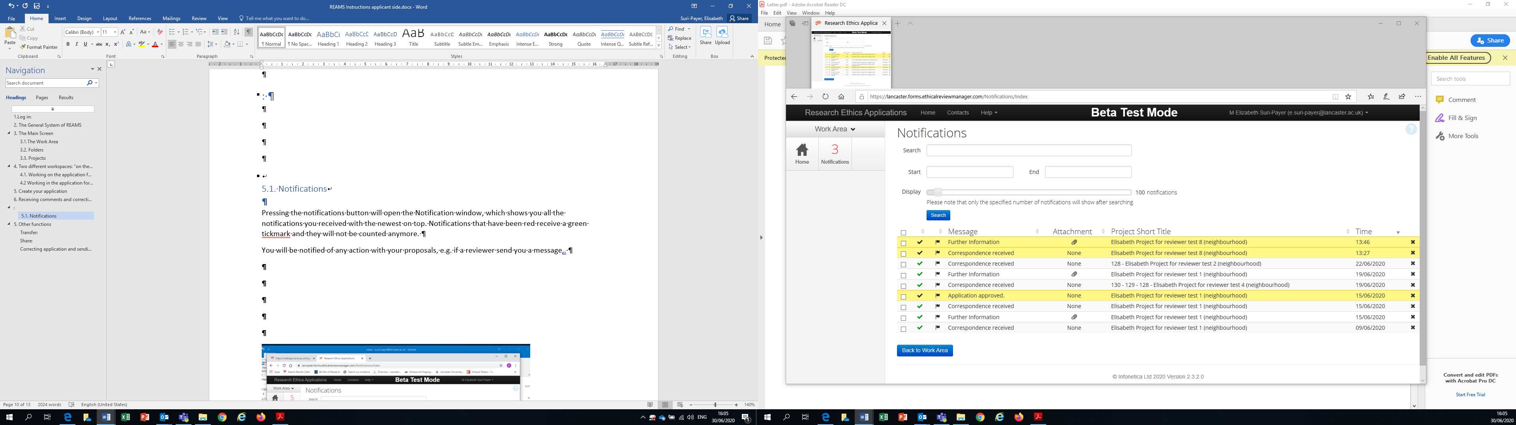
1
2
Figure 24- Notification window
Different columns in the notification row have different functions when they are clicked. If you click on the text under the “Project Short Title” column (green arrow (1) Figure 24) the application will open in the navigation overview page (Figure 23).
If you click the text in the column under “Message” (red arrow (2) Figure 24) the Message window will open (Figure 25):
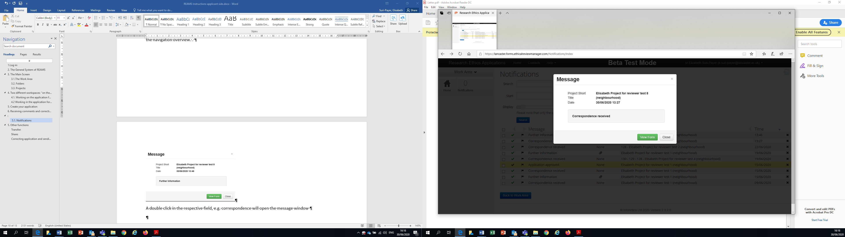
Figure 25- Message window
Press “View Form” and the application overview page of the respective application will open (Figure 26) on the correspondence tab (section 7.1).

7.1 Correspondence

Figure 26- Application navigation overview
Figure 26 shows a red box next to the “Correspondence” tab (red arrow) in the application overview page. This means that there is a correspondence waiting to be read. Click on “Correspondence” tab to open the correspondence field. The example in Figure 27 contains the comment “please make changes to PIS form” and an attachment (which is the PIS form with comments on it from the reviewer). You will also be notified of correspondence such as this in the notifications window by pressing the notifications button (section 7).
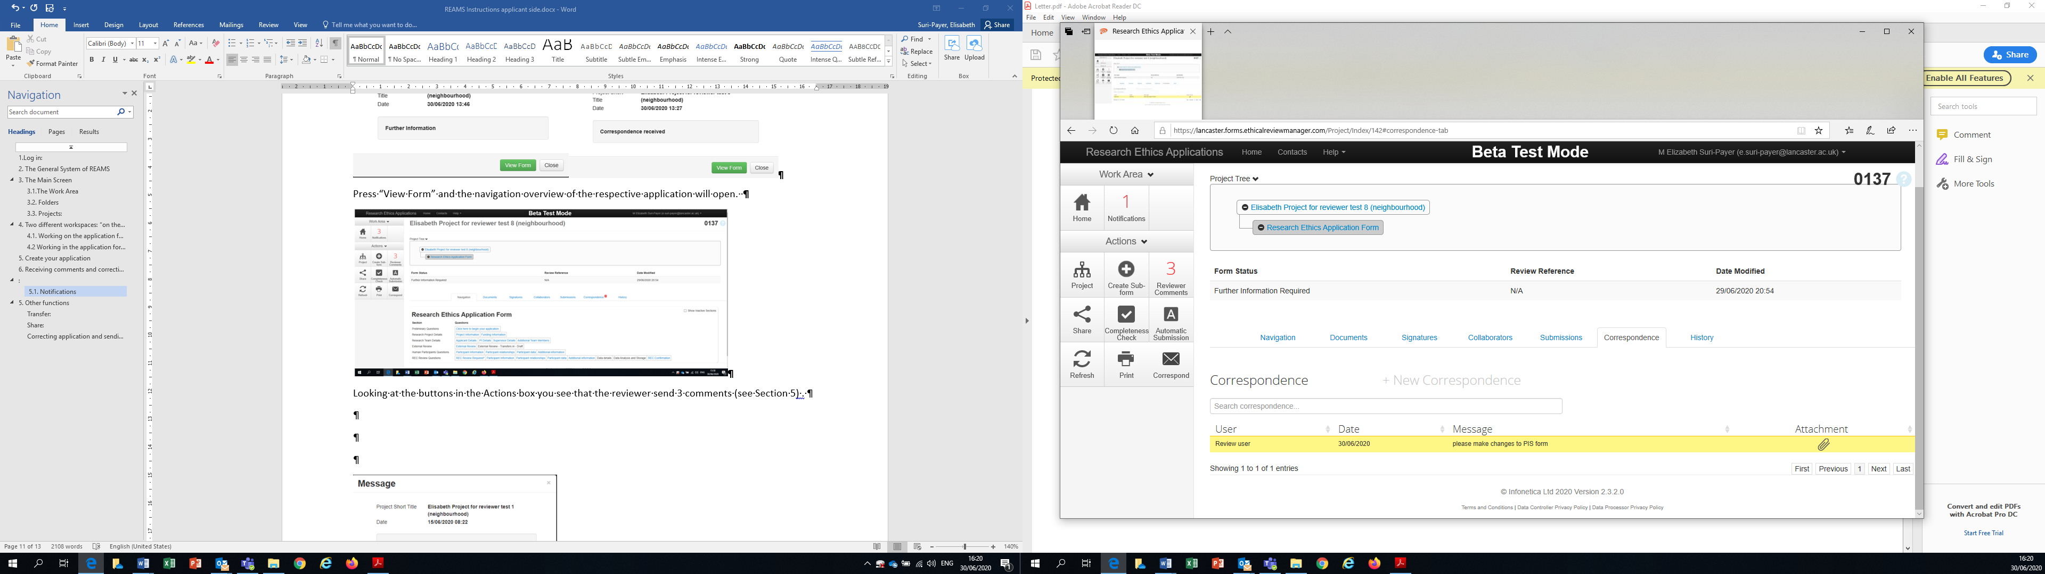
Figure 27- Correspondence

After clicking on the attachment another message appears, showing you the name of the file, which then can be download (opened or saved).
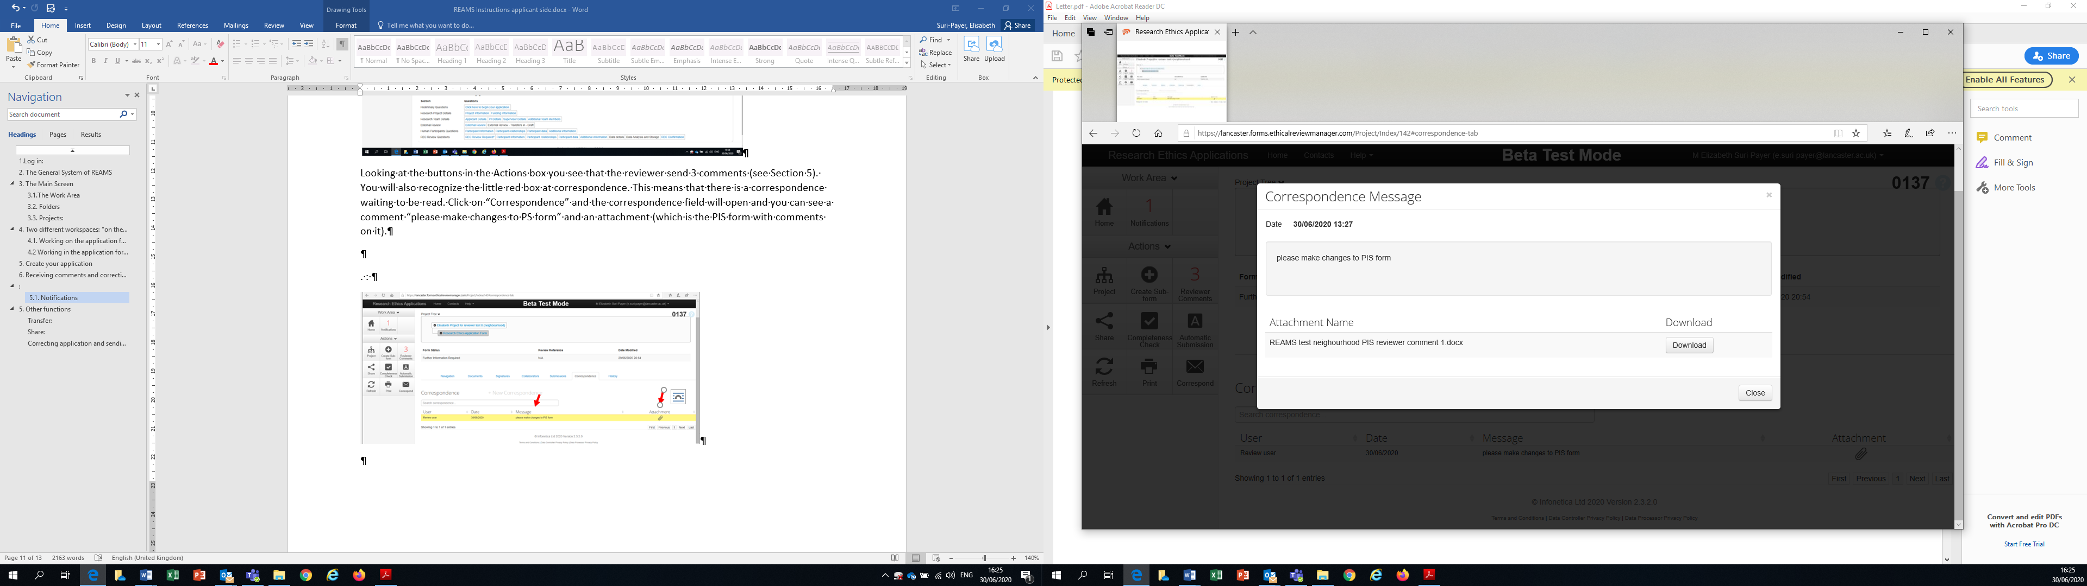
Figure 28- File download

8. Amendments
Please note, this section does not apply to amendments to any IRAS applications including those which require HRA approval and FREC approval. For guidance on amendments to applications which require HRA approval and FREC approval please see section 12.
Amendments to approved applications can be created through the ‘Sub-form’ function. Begin by opening the application which you wish to make changes to in the work area (section 3). Once the application overview page has been opened, click on the button “Create Sub-form” in the Actions box (shown by the red arrow (1) in Figure 29), the Create Sub-form window will then open (Figure 30).
1
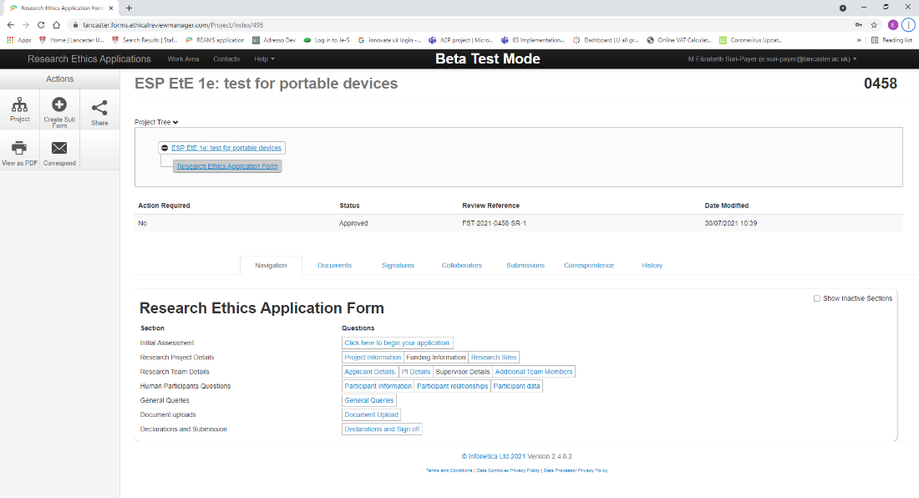
Figure 29- Create sub-form button
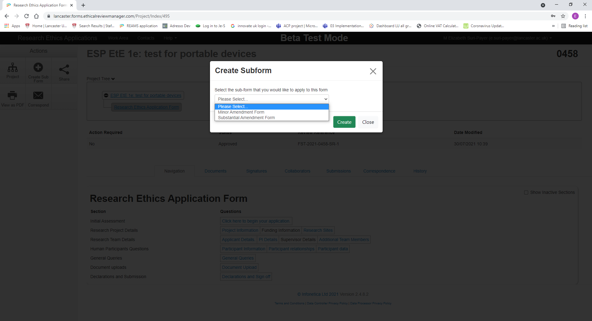

Figure 30- Create Sub-form
Choose either the minor or substantial amendment form (it is recommended that you check the amendment guidance on the REAMS web guidance website), and the relevant Amendment Form will then open. Click the blue box titled “Click here to begin your amendment” under the minor amendment sub-heading in the navigation tab and fill the form (shown by the Red box in Figure 31).
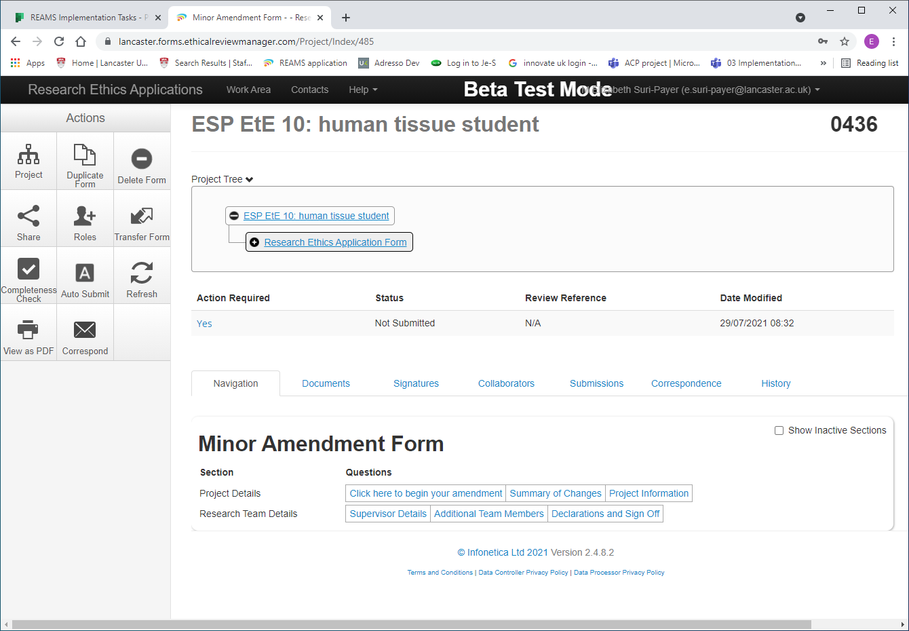
Figure 31
After you click “Click here to begin your amendment” you will be asked for the list of changes you would like to make. The chosen questions will then open up for your amendments. Please remember to number your amendments so that the reviewer is aware that they are looking at the latest version of your application. Minor amendments will automatically be approved, while substantial amendments will be sent to the FREC Chair for approval. It is possible to move from minor amendments to substantial amendments and visa-versa between different rounds of review.

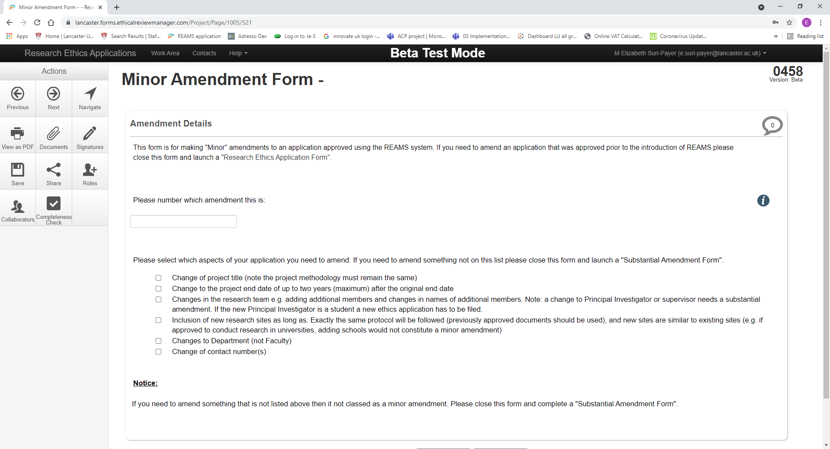
Figure 32- Minor amendments form
When making substantial amendments you will have to work your way through the form as if you would when creating a new application. However, you will still be able to view and edit your previous answers. Again, all the sections of your application which have previously been filled out and can now be edited are marked blue in the navigation tab in the application overview page.
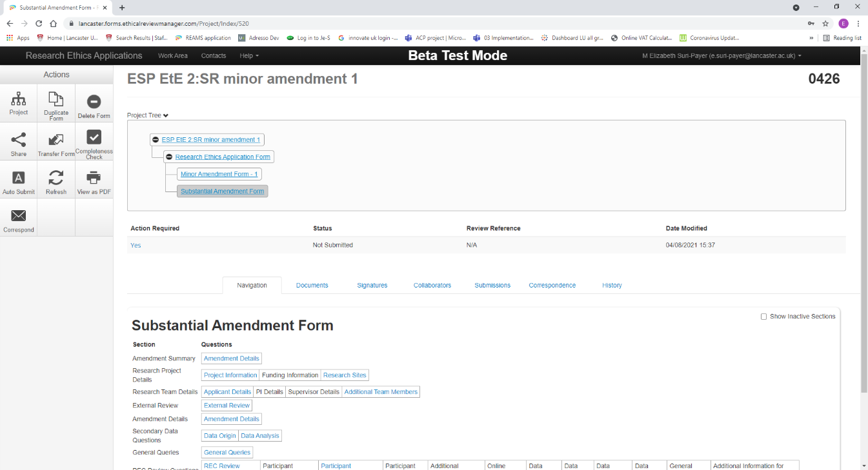
Figure 33- Substantial amendment form

Please note that you cannot amend your type of application. This means that if you would like to add participants to a human data only application, or to add social media online sources in your project then you will need to start a new application.
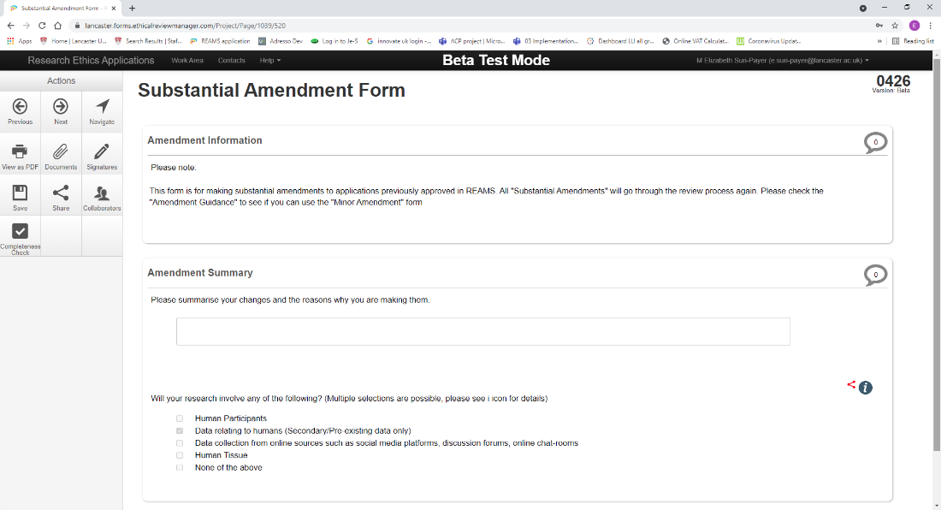
Figure 34

9. Other functions
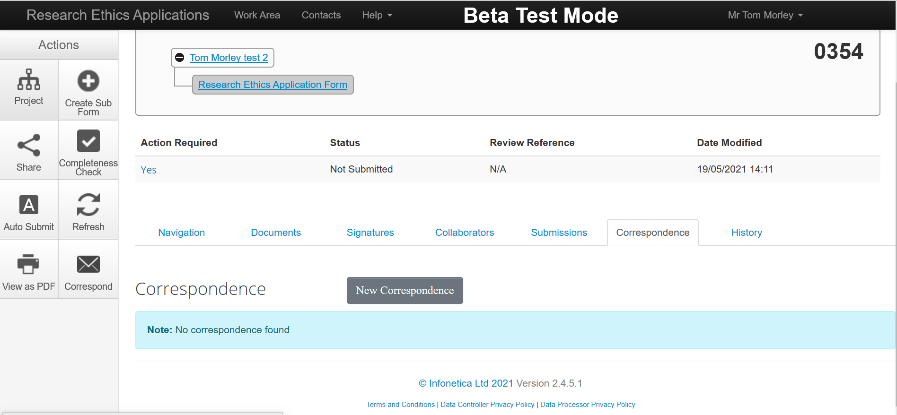
5
2
4
3
1
Figure 35- Application navigation overview: Actions buttons functions

9.1. “Share” your application
If you are the Principal Investigator (PI) you can share the application form with your Principal Applicant (PA) or your students, so that they can also work on the form with you. If you are a student you can share the form with your PI or other students. Press the share button in the Application Overview Actions box (Red arrow (1) in Figure 35) and add the E-mail address of the colleagues whom you want to share the REAMS application form with.
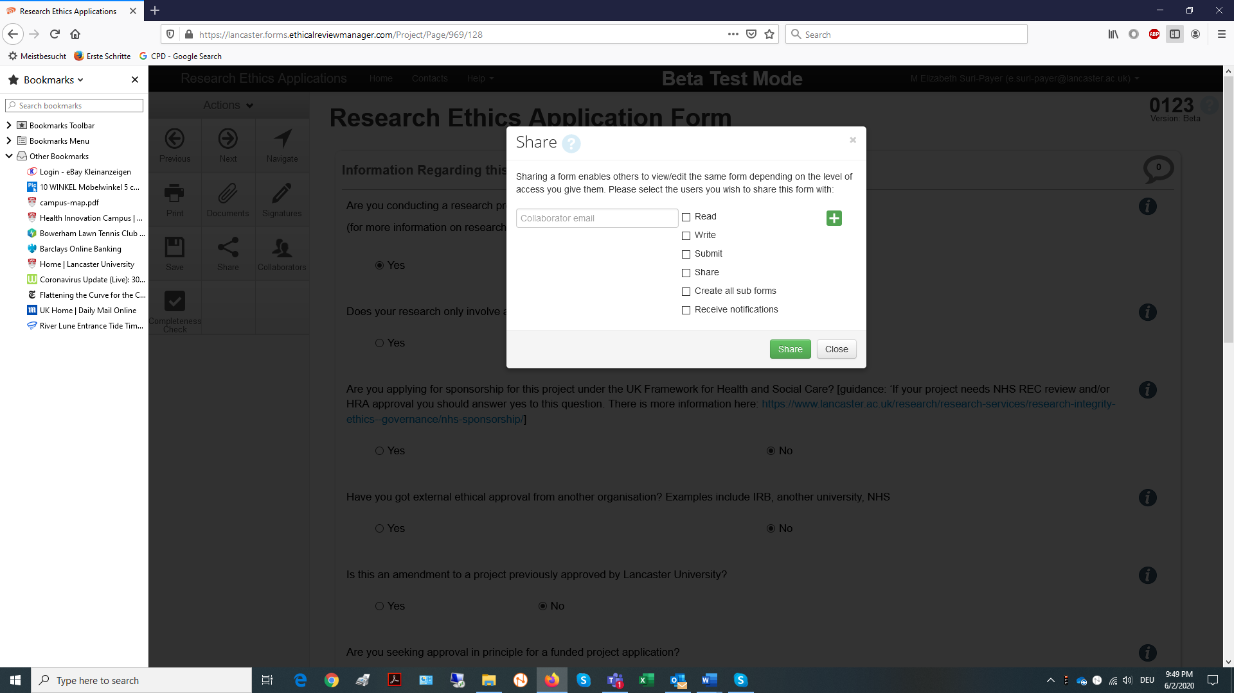
Figure 36 - Share application

9.2. Correspondence in the Application Overview Actions box
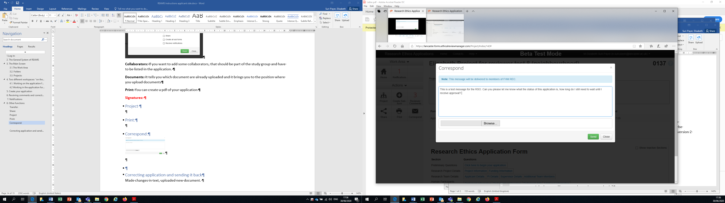
Figure 37- Correspondence
You can send a message though REAMS to your faculty REO instead of using E-mail. Press the ‘new correspondence’ button in the application overview page (Green arrow (2) in Figure 35). This correspondence will be sent automatically to the Research Ethics Officer. You can also upload additional information using the browse button under the correspondence box (Figure 37).

9.3. Print your application or view as a PDF
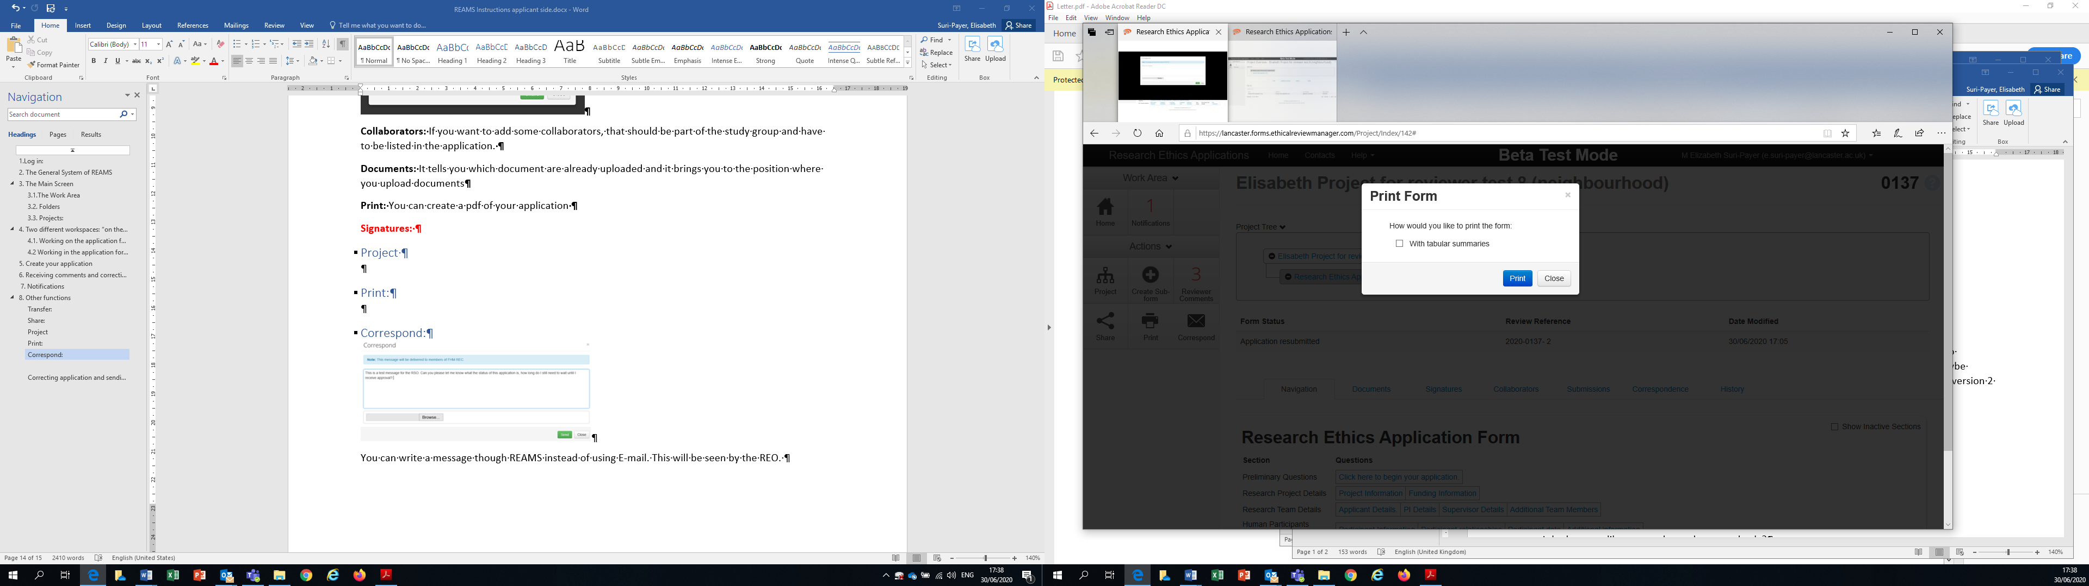
Figure 38- Printing your application.
Pressing the “View as PDF” button in the application overview page action box (Blue arrow (3) in Figure 35) will provide you with a pdf of your entire application in one document which can be printed.
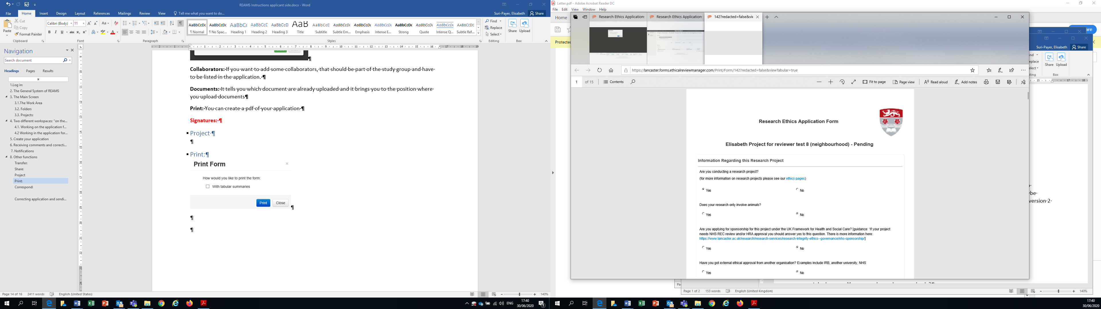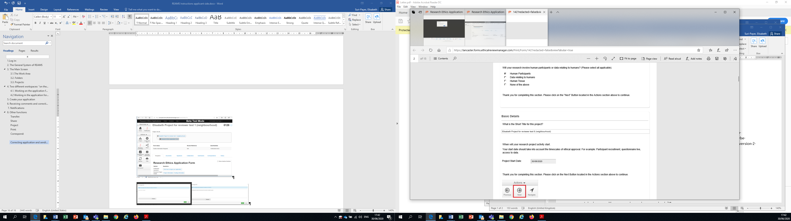
Figure 39- PDF of document

9.4. Automatic submission
Pressing the “Auto Submit” button in the application overview page (Yellow arrow (4) in Figure 35) allows you to enable or disable the automatic submission of your application when all signatures are completed.

9.5. Project:
The ‘Project’ button in the actions box of the application overview page (Purple arrow (5) Figure 35) provides an overview of the application and its current status. Clicking this button will open the ‘Project Overview’ page shown in figure 41. The “Forms tab” provides an overview of the current status of forms associated with the application, the “Submitted Documents” tab lists all the uploaded (and also the hidden (deleted)) application documents. The “Transfers” tab provides an overview of transferred documents, whilst the “History” tab details all the steps that the application form has been through.
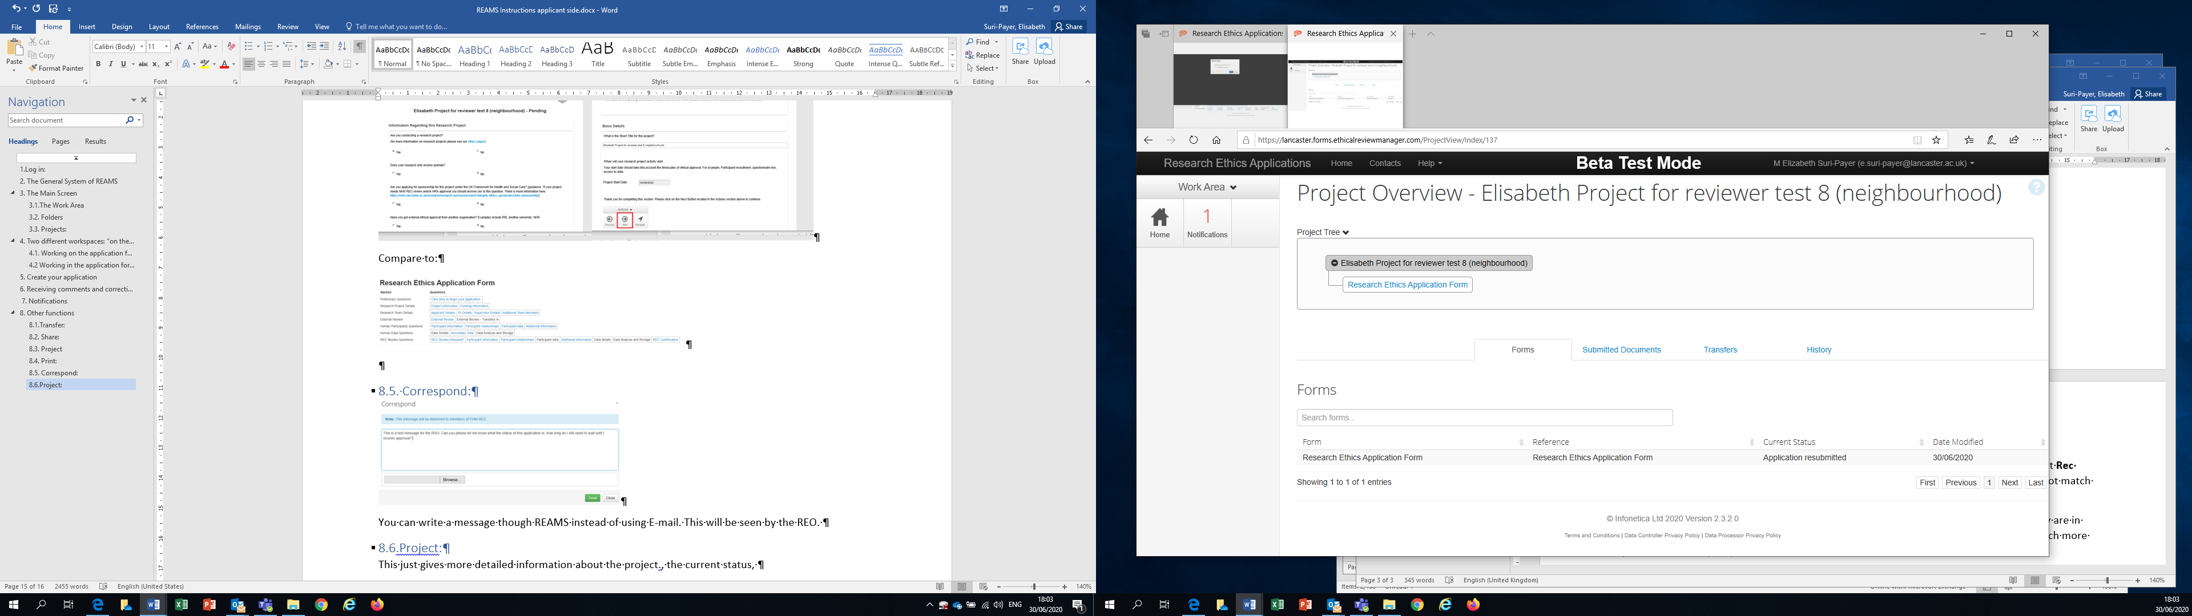
Figure 40- Project overview

9.6. Refresh button in Actions box of applicant overview site

Figure 41 Refresh action buttons
Pressing the “Refresh” button (Shown by the blue arrow in Figure 42) will refresh your application.

9.7 Adding contacts in REAMS and changing your personal details

We strongly recommend that you check to see if your personal contact details in REAMS are correct and regularly update them. To view and update your personal details click on the down arrow next to your name and select ‘Personal details’. Then view and update your information in your personal details page.
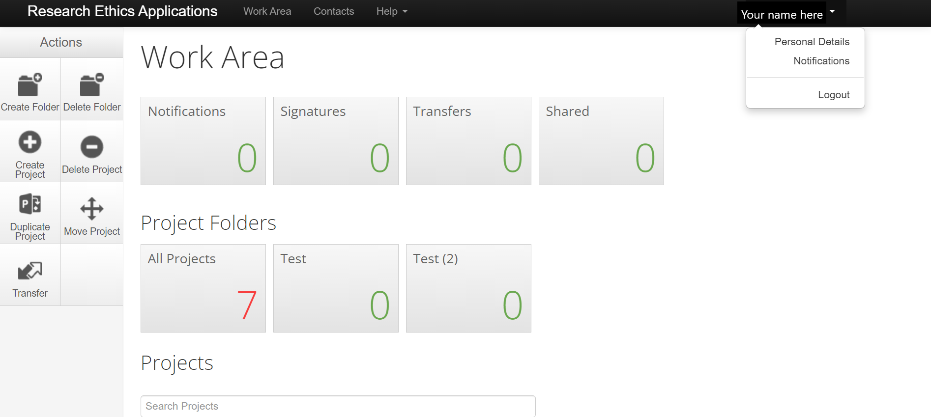
Figure 42- Personal details
A ‘Contacts’ tab can be found in the bar at the top of every page within the REAMS system (shown by the blue box in figure 43).

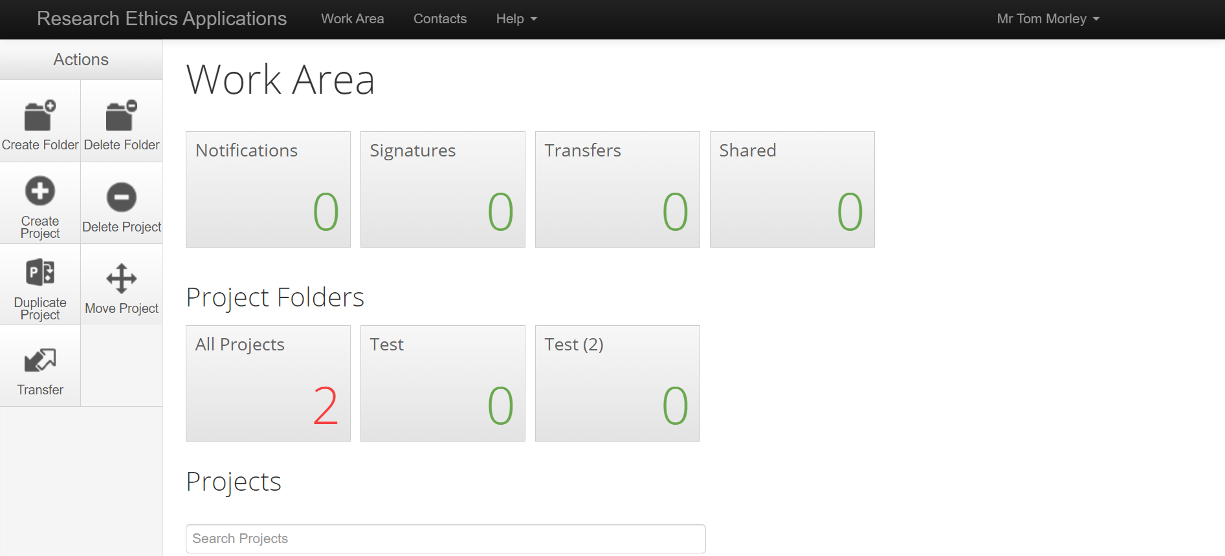
Figure 43 Contacts tab
Within the contacts tab you can add useful contact details into the system, such as yourself, your supervisor, co-Investigators and other members of your research team. This allows you to automatically add contact information from these saved contacts to your ethics application into the REAMS form, (such as when you are adding your supervisor or the projects PI details into the application).

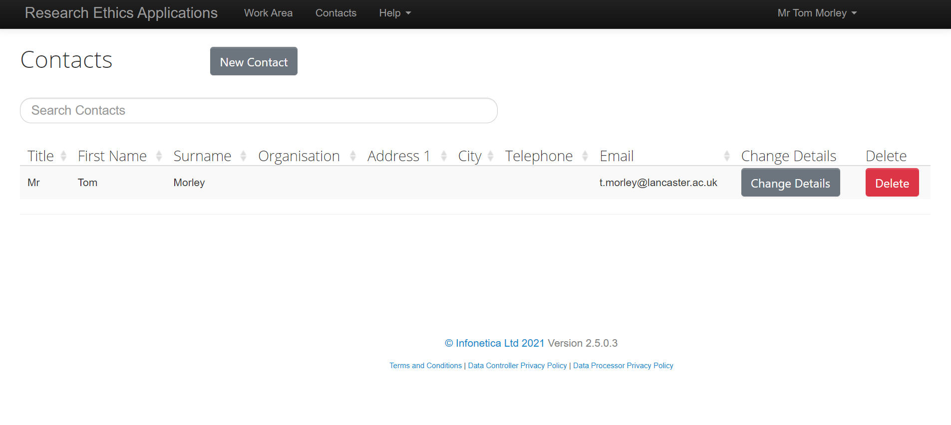
Figure 44 Contacts

9.8 Useful contacts
For ethics-related queries please contact your Faculty Ethics Officer:
- For FHM and FST related queries
- For FASS and LUMS related queries
For questions related to the REAMS system please email reams-support@lancaster.ac.uk
Further advice and guidance can be found on your Faculty Research Ethics web page:
- FASS-LUMS
- FST
- FHM
You can also find a list of useful contacts under the help tab within REAMS. Simply hover over the Help tab and click on ‘Contact information’.

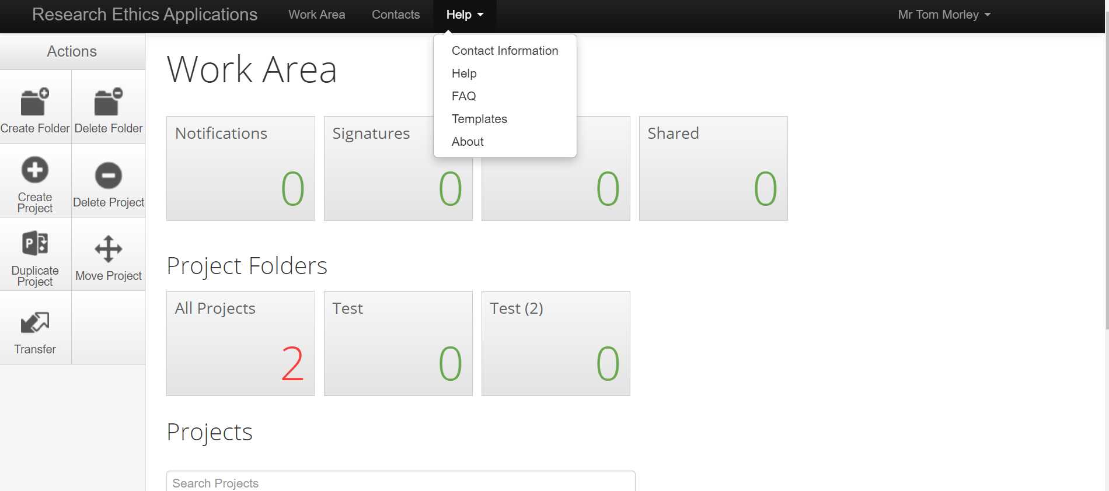
Figure 45- Useful contact information

Appendices

10. Appendix 1: Guidance specifically for staff and PhD students in the Economics Department
Before accessing the REAMS system to submit your application you will need to complete the LExEL Statement available here http://lums-research.lancs.ac.uk/orsee/LExEL_Ethics_Statement.pdf * and obtain the Director or the Lab Manager of LExEL’s signature on the Statement. You will need to upload the Statement in REAMS, along with any other supporting documents, such as participant information sheet and consent form. (There is a section in REAMS which prompts the user to upload documents). If you have any questions about LExEL you should contact the Director or the Lab Manager of LExEL in the Economics Department. If you have any questions about the ethics process you should contact fass.lumsethics@lancaster.ac.uk.
*To note, you will need to be connected to the VPN to access the Statement via the link.

11. Appendix 2: Guidance specifically for staff and PhD students requiring HRA approval and Faculty Research Ethics Committee approval

Introduction
To note, the guidance below does not apply to IRAS applications which need NHS REC review. An example of an IRAS application which needs NHS REC review is one where NHS patients will be recruited to participate in a research project. This type of project cannot be processed in REAMS and the applicant should follow the guidance here instead. If you are unsure of whether your application needs NHS REC review you should refer to the HRA website and use the ‘decision tool’ which are accessible here under ‘Step 1’. IRAS applications that need NHS REC review should be submitted directly to the Clinical Research Support Officer, by email to sponsorship@lancaster.ac.uk for processing.

IRAS applications which can be submitted in REAMS
*For new applications which require HRA approval and Faculty Research Ethics Committee (FREC) approval the applicant should use REAMS to submit their IRAS application form to their FREC for review; if they are naming Lancaster University as their sponsor on the IRAS form. (An example of an IRAS application which requires HRA approval and FREC approval is where NHS staff only will be recruited to participate in the project). For this type of IRAS application the applicant should answer the questions in REAMS to indicate they need HRA approval from the NHS. When prompted in REAMS the applicant must also upload their IRAS form in pdf format and all supporting documents including, but not limited to: participant information sheets, consent forms, interview questions, etc. The application will be processed and reviewed by the FREC in REAMS, in the first instance.

If the applicant has not already done so they should also contact the Clinical Research Support Officer, email sponsorship@lancaster.ac.uk, to let them know that they have submitted their IRAS application in REAMS for FREC review. Further guidance can be found here.

12. Amendments to applications which require HRA approval and FREC approval
Amendments to this type of application will NOT be processed in REAMS. Instead, they will be processed by the Clinical Research Support Officer (CRSO). Please follow the guidance below:
Amendments to the approved project must be submitted directly to the CRSO @ sponsorship@lancaster.ac.uk as per the University guidance here. The CRSO will send your amendment to the Chair/Deputy Chair of your Faculty Research Ethics Committee for review/approval and they will notify you of the outcome.

Version 3-11-21

