Title of Presentation

First Author¹, Second Author¹, Presenting Author², and Final Author^{1,2}
¹ Department of Quantum Mechanics, Institute of Advanced Studies, Nova City, NV1 2AB, UK
² Institute of Experimental Physics, Quantum Leap University, Quantum City, QC4 3PQ, UK

Abstracts should be written in English. Each abstract is limited to one A4 page in vertical format. The font should be 11 Arial, single-spaced. At the top of the document, centered in bold, caps and lower case, type the title of the presentation. Insert a blank line. All authors should be listed on the next line(s) followed by their institution(s). Use numbers to indicate the different affiliations of the authors. Underline the name of the author who will present at the conference. The author list and author affiliation list should be centered. Insert another blank line between the authors and the body of the abstract.
Start each paragraph of the body of the abstract with a tab.
Each figure included in the abstract should be accompanied by a caption in 11-Arial. Be sure that figures are neatly prepared and fit within the space limitations.
Cite references [1,2] in the text with a numeral in brackets. Number all references sequentially as they appear in the text, starting with 1. Make all references complete bibliographic citations as per examples below, including author, place of publication, volume, year, and page number. References should follow the main text of the abstract.

Please do not modify the format of this MSWord abstract template.

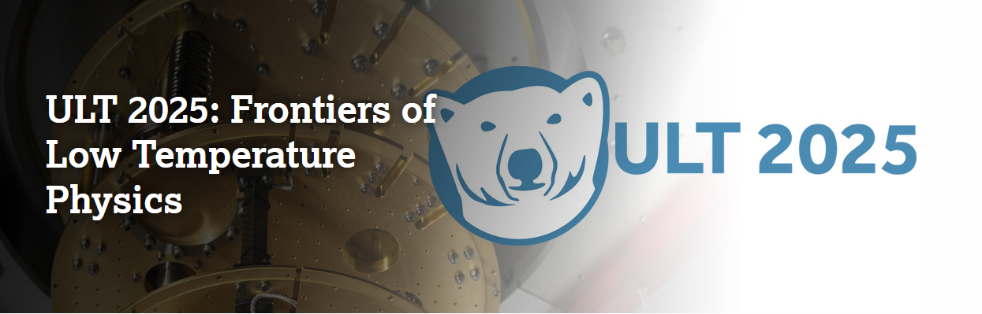

Figure 1: My figure.

[1] A. Author et al., Phys. Rev. B 1, 13 (2022).
[2] A. Author and B. Author, Nature 12, 1 (2024).

