Version 2.0 – Updated 17/11/2023

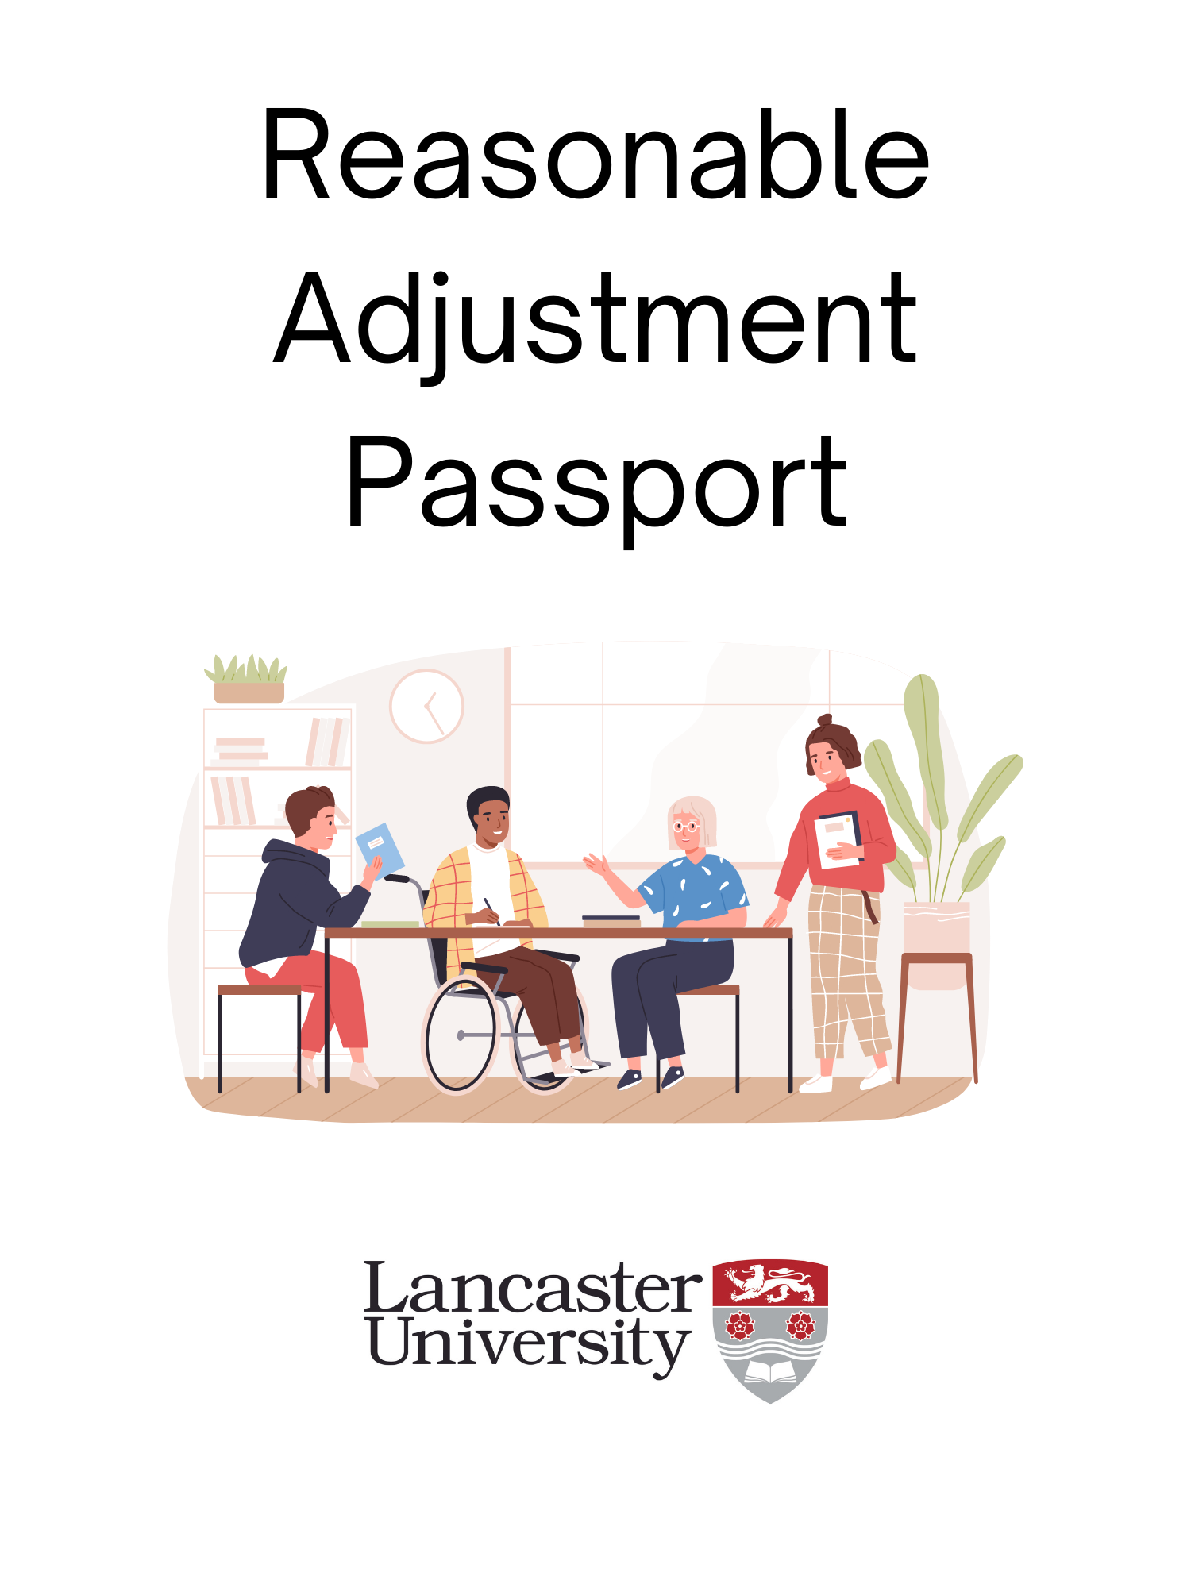

# Purpose of this Reasonable Adjustment Passport

The purpose of this Passport is to formally document your needs as an individual. At Lancaster University, we’re committed to empowering every individual to excel in our inclusive culture, and to creating a supportive environment where no one faces prejudice or discrimination. This Passport should be used to document any additional support needs you may have, or adjustments to your working practices or processes that you might require.

Completing this Passport is voluntary, however we encourage anyone who may benefit from additional support, or from having their disability or health condition documented, to complete one. The Passport can be requested by you as an employee, or can be offered by your line manager, but ultimately, as an employee you “own” this document.

The information contained in this Passport will not be shared without your consent. If you would like this information to be shared with your HR Advisor/Partner, or if you would like to request a referral to Occupational Health as part of agreeing these reasonable adjustments, please indicate your consent to share information in section 4.

Formal reviews and revisions of the agreed support/adjustments should be documented using Appendix 1 (page 8).

# Section 1: My Details

The information provided in this Reasonable Adjustment Passport is confidential between you as an employee and your line manager and will not be shared without your written consent.

A copy of this Passport should be kept by both you and your line manager. It is the employee’s responsibility to ensure this is shared, if necessary, with new or secondary line managers, and in the case of job role changes or departmental moves.

Digital or electronic signatures may be used.

|  |  |
| --- | --- |
| Name of employee: |  |
| Employee Signature & Date: |  |
| Name of line manager: |  |
| Line Manager Signature & Date: |  |
| Department/Division: |  |

# Section 2: My Personal Circumstances

In the boxes below, please give as much information as you are able to, and are comfortable with, about your disability and/or health condition and its potential impact(s) upon you at work.

We recognise that there are different ‘models’ of disability, including the social model of disability, and the medical model of disability. In filling in this Passport, and in thinking about the challenges you might face at work, you are able to include barriers which arise both directly from your health condition/disability, and those which relate to the social environment/workplace.

Space is provided for information about 2 conditions, however, you may wish to add more rows as necessary.

|  |
| --- |
| Give a brief description of your disability(s) and/or health condition(s) including (if appropriate) how long you have had the health condition or disability, and any medical/specialist assessments or treatment you may have had or are waiting upon. |
| Condition 1: |
| Condition 2: |

|  |
| --- |
| What are the impacts of your disability and/or health condition upon you at work? |
| Condition 1: |
| Condition 2: |

|  |
| --- |
| (Optional) If there are fluctuations in how your disability and/or health condition impacts you at work depending on flare-ups or cyclical effects, please detail below how you may feel on a ‘good day’ or a ‘bad day’. |
| Condition 1: |
| Condition 2: |

|  |
| --- |
| (Optional) If there is any additional information that you would like your line manager to be aware of i.e., signs you are unwell and/or struggling; preferences regarding communication; any plans you might have in place for addressing increased levels of symptoms, please feel free to share these below: |
| Condition 1: |
| Condition 2: |

# Section 3: Reasonable Adjustments

This next section asks you about Reasonable Adjustments to your working pattern, arrangements, or environment which you would expect to minimise any barriers or difficulties that you might face at work (if the Reasonable Adjustments were not agreed and put in place).

If you know what adjustments would be likely to help you at work, you should enter these in the table below and discuss them with your manager as part of the meeting to complete this document. It may also be the case, that whilst you’re aware of the difficulties or barriers that you might face, you’re not certain what adjustments are possible. In those instances, we encourage a conversation between you and your manager (whilst looking at this document) to see whether there are changes you might try.

## Requested Changes to My Working Practices

I believe the following changes to my working patterns or practices would minimise or reduce any barriers or difficulties I might face in the workplace due to my health condition or disability (or the effects of these):

*Please add more rows to this table if required.*

|  |  |  |  |
| --- | --- | --- | --- |
|  | Change to working practice[1] | How might this change reduce difficulties, barriers or disadvantage I experience due to my health condition or disability? | Agreed?  (If not agreed, line manager must detail the reason for this below.) |
| 1. |  |  | ☐ |
| 2. |  |  | ☐ |
| 3. |  |  | ☐ |

# Section 4: Agreeing These Alterations to Working Practices

If all the requested changes to your working practices have been agreed in the table above, then all that remains for you to do is to agree a review date with your line manager. The review of agreed reasonable adjustments should be carried out using the form in Appendix 1 of this document (page 8).

If your manager is unable to agree to all the reasonable adjustments requested above, then please use the table below to record alternative reasonable adjustments that you have discussed and whether you are happy with these adjustments.

## Alternative reasonable adjustments

|  |  |  |
| --- | --- | --- |
| Original requested change to working practice | Suggested alternative | This alternative adjustment has been agreed between me as an employee, and my line manager. (Delete as applicable) |
|  |  | Yes/No |
|  |  | Yes/No |

If you and your line manager are happy with the requested and/or alternative adjustments as above, please sign below to indicate the date that you have agreed these (digital signatures are acceptable).

|  |  |  |  |
| --- | --- | --- | --- |
| Employee Signature: |  | Date: |  |
| Manager’s signature: |  | Date: |  |

Do you consent to this information being shared with:

|  |  |  |  |
| --- | --- | --- | --- |
| Human Resources? | Yes | No | Date: |
| Occupational Health Services? (if required) | Yes | No | Date: |

This consent may be updated, offered, or revoked using a Review of Agree Reasonable Adjustments (page 8).

# Section 5: Date of Review

It is important that you and your manager review the agreed reasonable adjustments annually (at least) using the review form in Appendix 1. If you are able to agree the date of the review of these adjustments at this stage, please record this below:

|  |  |
| --- | --- |
| Expected date of next review: |  |

# Appendix 1 – Review of Agreed Reasonable Adjustments

Please fill in the information below when reviewing the reasonable adjustments that you have previously agreed on pages 5-6. If you and your line manager are happy that the reasonable adjustments implemented are effective, you may decide to keep those adjustments in place without change.

If, however, any of the reasonable adjustments agreed are either ineffective, or their continuation is otherwise impractical, this section can be used to agree alternative or additional adjustments.

|  |  |
| --- | --- |
| Date of Review: |  |

Following discussion between you and your line manager, please choose from one of the following four options:

|  |  |
| --- | --- |
| All the previously agreed reasonable adjustments have been effective and will remain in place until the next review date.  Date of next review: ________________ |  |
| The previously agreed reasonable adjustments were effective but due to a change in my health/disability need to be changed. |  |
| Some of the previously agreed adjustments were suitable.  However, others did not have the anticipated positive effect, or are no longer feasible, and so are to be discontinued, and new reasonable adjustments agreed below. |  |
| The previously agreed reasonable adjustments did not have the anticipated positive effect, or are no longer feasible, and so are to be discontinued, and new reasonable adjustments agreed below. |  |
| I no longer require reasonable adjustments to my role. |  |

If a change in the reasonable adjustments has been indicated above, please fill in the following table detailing the alternative reasonable adjustments agreed.

## Alternative reasonable adjustments

|  |  |  |
| --- | --- | --- |
| Original requested change to working practice | Alternative reasonable adjustment | This alternative adjustment has been agreed between me as an employee, and my line manager.  (Delete as applicable) |
|  |  | Yes/No |
|  |  | Yes/No |

Do you consent to this information being shared with:

|  |  |  |  |
| --- | --- | --- | --- |
| Human Resources? | Yes | No | Date: |
| Occupational Health Services? (if required) | Yes | No | Date: |

If you and your line manager are happy with the review of your reasonable adjustments as above, please sign below to indicate the date that you have agreed these (digital signatures are acceptable).

|  |  |  |  |
| --- | --- | --- | --- |
| Employee Signature: |  | Date: |  |
| Manager’s signature: |  | Date: |  |

1. Note: If you are requesting a change to your working pattern which would be considered a flexible working request, the process for agreeing a flexible working pattern is set out in the [Flexible Working Policy](https://portal.lancaster.ac.uk/intranet/services/people/pay-recognition-and-reward/flexible-working-request/). All requests for flexible working must be handled in accordance with that policy.