February 2008

Lancaster University Flooding Project Newsletter 1


Welcome to the first edition of our project newsletter! Thanks to you – our participants – the project has got off to an excellent start, so we wanted to let you know what’s been happening since your first interview.


In this edition, you’ll find all the latest news about the project as well as details of how the results are being used to feedback to key agencies. We’ve also included some telephone numbers that you may find helpful during your recovery from the floods.

We’ll be producing this newsletter on a regular basis during the project so, if you have any stories or photographs that you would like included in the next edition, please send them to us at the address below.

Thanks again for your help – we couldn’t do this without you!

Beccy and Will

Project update: the story so far

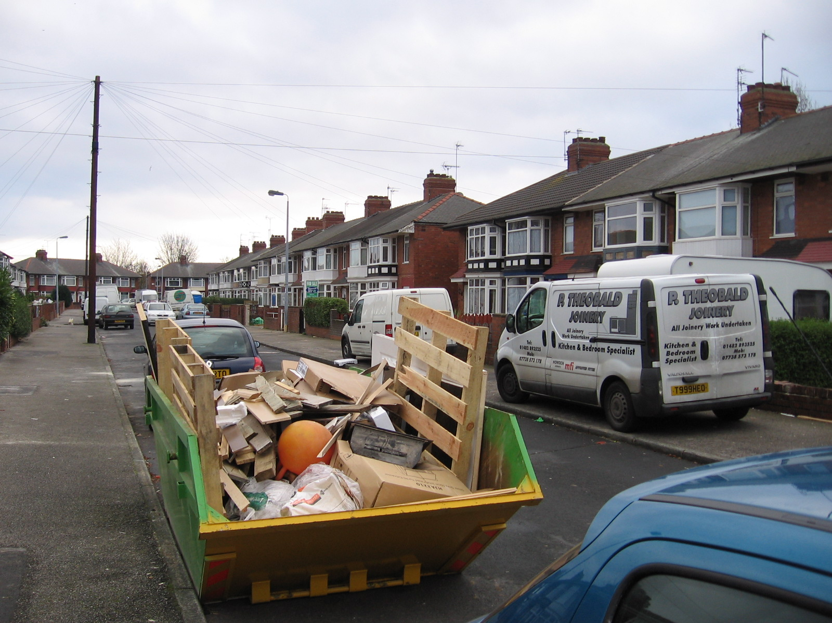
The good news is that, since the project started in October, Beccy and Elham have interviewed over 45 people – most of whom are now keeping flood recovery diaries for us.

The stories we’ve heard have been incredible, with people showing amazing amounts of courage and persistence in dealing with the floods, so thank you for sharing your experiences with us.

Beccy, the project’s researcher, is currently working to collect the first batch of diaries and to make sure that everyone receives their first payments. During her visit, she will also explain about the group discussions that will be taking place in April (see ‘next steps’ – overleaf).

Finally, you may also have noticed that we’ve had some media interest in the project, which resulted in a recent appearance on the front of the Hull Daily Mail!

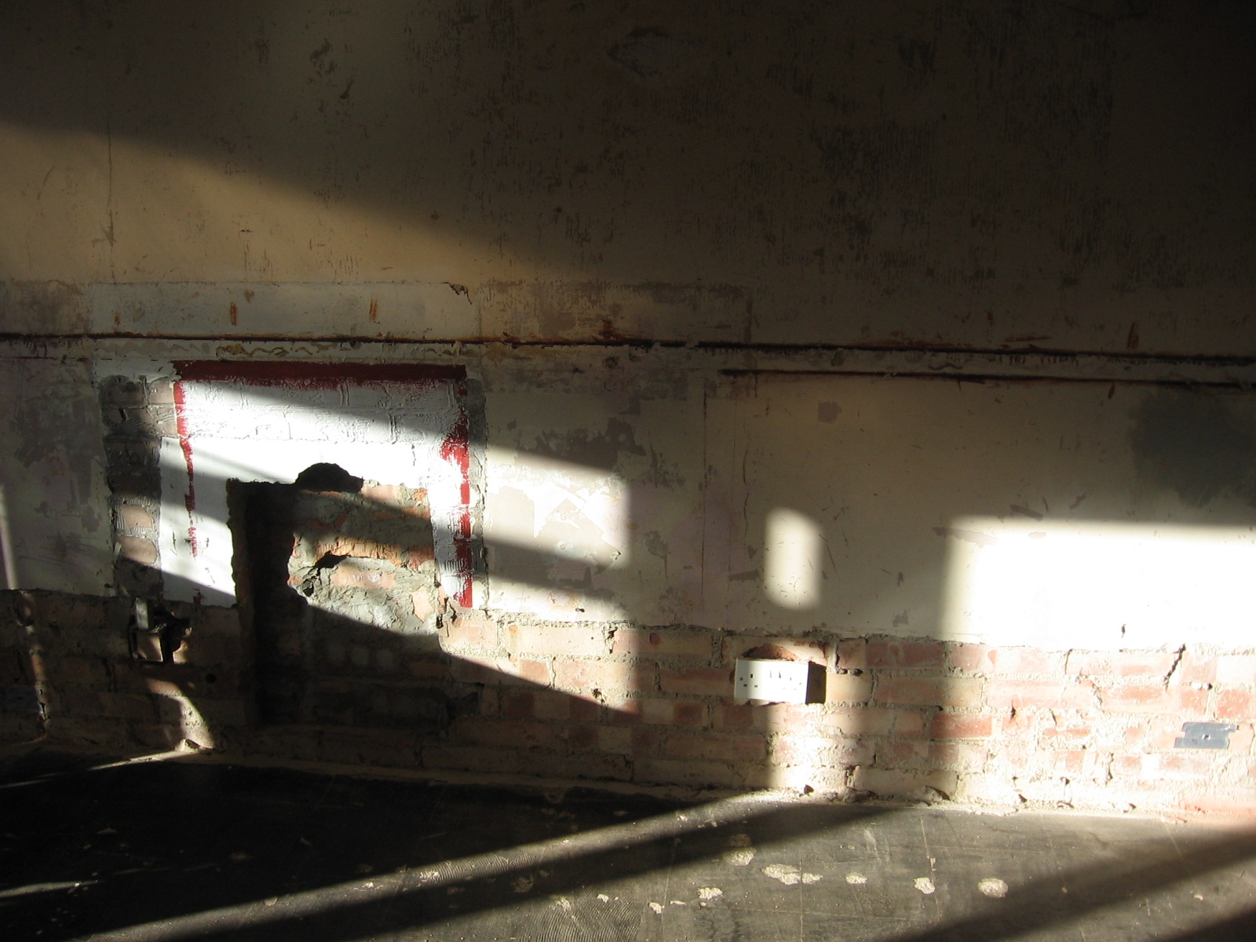
Next steps…

Your interviews and diaries are providing us with valuable information about what it feels like to be flooded. Your thoughts and experiences will allow others to understand what you have been going through, and ensure that lessons can be learnt to help those who are flooded in future.
Findings

This study’s results will be used to provide feedback to a number of organisations. We will be having regular meetings with the following groups to ensure that they can learn from the findings.

- Hull City Council
- Environment Agency
- Hull CVS
- National Flood Forum
- North Bank Forum
- Humber PCT
- Goodwin Trust
- University of Hull
- University of Cumbria
- DEFRA
- Association of British Insurers

We are also working with the University of Hertfordshire to provide evidence to the Pitt Review – the government’s national-level inquiry into the summer floods.

However, we want to make sure that you have the chance to get involved with the project’s findings, so that you can tell us how you think things could be improved. That’s why we’ll be inviting you to take part in a group discussion this April.

At the discussion, you’ll be able to meet and talk to some of the other people who are keeping diaries for our project. We’ll also be asking you to tell us what you think the priorities should be for the future in terms of investment, help and practical support for flood victims.

The date and location of the discussion will be confirmed nearer the time. In the meantime, if you have any questions, please contact Beccy.

Further help and advice

During our research we’ve come across the following local and national organisations which may be able to help you with your recovery. Some provide practical and financial assistance, while others can give medical and emotional support, so do give them a call if you need some help.

- The National Flood Forum – For builders, flooding and insurance issues. Contact Paul Hendy 07747702299
- Samaritans – Emotional support for those experiencing distress. Contact the Hull branch on 01482 323456 or call the national 24-hour helpline: 08457 909090 www.samaritans.org.uk
- Citizens’ Advice Bureau Hull – Charlotte Street Mews, Hull. Tel: 01482 224608
- Hull Council for Voluntary Services – Grants and flood funds. Contact Mike Scott Tel: 01482 324474
- Speak to your family doctor or contact NHS Direct on 0845 4647 (24 hours) for access to help and support – counselling etc.
- Hull City Council Flood Advice Service Tel: 01482 300310
- Local Churches – For support and assistance
- The Salvation Army – Hull branch 01482 323897
- Age Concern – Help for the elderly – Contact the Hull branch on 01482 324644 or call the national helpline: 0800 00 99 66

If you have come across any useful contacts that you would like to tell others about, please let us know and we will publish them in a future issue of this newsletter.

